# **Web-based Interactive Map of MSU-IIT**

using OpenStreetMap and OSM Buildings

A Capstone Project

Presented to the

Faculty of the Information Technology Department

Mindanao State University - Iligan Institute of Technology

In Partial Fulfilment

Of the Requirements for the Degree of

Bachelor of Science in Information Technology

by

Amba, John Vincent

Revelo, Paul Emmanuel

Erik Louwe R. Sala, MSIT

Faculty Adviser

May 2016

MINDANAO STATE UNIVERSITY

ILIGAN INSTITUTE OF TECHNOLOGY

CHED Center of Excellence for Science and Technology

Andres Bonifacio Avenue, Tibanga Highway, 9200 Iligan City

**INFORMATION TECHNOLOGY DEPARTMENT**

**School of Computer Studies**

# RECOMMENDATION SHEET

The Thesis Entitled

Web-based Interactive Map of MSU-IIT

using OpenStreetMap and OSM Buildings

Researchers and Project Developers:

Amba, John Vincent

Revelo, Paul Emmanuel

And submitted in partial fulfillment of the requirements of the Bachelor of Science in Information Technology, has been examined and recommended for oral defense.

**Erik Louwe R. Sala, MSIT**

Thesis Adviser

______________________________

Date

MINDANAO STATE UNIVERSITY

ILIGAN INSTITUTE OF TECHNOLOGY

CHED Center of Excellence for Science and Technology

Andres Bonifacio Avenue, Tibanga Highway, 9200 Iligan City

**INFORMATION TECHNOLOGY DEPARTMENT**

**School of Computer Studies**

# APPROVAL SHEET

The Thesis Entitled

Web-based Interactive Map of MSU-IIT

using OpenStreetMap and OSM Buildings

After having been reviewed, is hereby approved by the following members of the thesis committee:

**Cenie M. Vilela – Malabanan, Ph. D. Zarah Mae Nubio Fabricante**

Panel Member Panel Member

__________________________________________ ___________________________________

Date Date

**Atty. Eddie Bouy B. Palad Erik Louwe R. Sala, MSIT**

Panel MemberThesis Adviser

_______________________________ ______________________________

Date Date

MINDANAO STATE UNIVERSITY

ILIGAN INSTITUTE OF TECHNOLOGY

CHED Center of Excellence for Science and Technology

Andres Bonifacio Avenue, Tibanga Highway, 9200 Iligan City

**INFORMATION TECHNOLOGY DEPARTMENT**

**School of Computer Studies**

# ACCEPTANCE SHEET

The Thesis Entitled

Web-based Interactive Map of MSU-IIT

using OpenStreetMap and OSM Buildings

After having been recommended and reviewed, is hereby approved by the Department of Information Technology, School of Computer Studies, Mindanao State University – Iligan Institute of Technology.

**Chona B. Que Esteves, MBM** **Alquine Roy F. Taculin, MSCS**

Chairperson Dean

Department of Information Technology School of Computer Studies

# ACKNOWLEDGEMENT

# ABSTRACT

While interactive maps greatly influence the economic advantages of an organization, it has been a challenge for researchers to build a virtual map that is compatible with today and the future’s expanding technical requirements.

Previous local studies systems show virtual visualizations of the campus of MSU-IIT and a few travel locations in Iligan City by providing different multimedia content such as 3D maps, panoramic images and PDFs. However, it was discovered that these systems were made as static applications with depreciated programming libraries.

This capstone project aimed to develop a dynamic web application using OpenStreetMap and OSM Buildings and by adapting and improving the functionalities while addressing the problems of the previous studies.

The project was able to establish the requirements of a dynamic interactive map based on four modules namely map, draw, content and search. Although with concrete frameworks, technical and design restrictions were experienced as the functionalities from used programming libraries were limited. Whereas the data obtain from thirty respondents using System Usability Scale showed positive feedback in which the administrator group were energized to the potential of the system.

**Keywords:** *Interactive Maps, Campus Maps, WebGL, OpenStreetMaps, OSM Buildings, System Usability Scale*

# TABLE OF CONTENTS

Web-based Interactive Map of MSU-IIT 1-0

RECOMMENDATION SHEET 1-1

APPROVAL SHEET 1-2

ACCEPTANCE SHEET 1-3

ACKNOWLEDGEMENT 1-4

ABSTRACT 1-5

TABLE OF CONTENTS 1-6

LIST OF FIGURES 0

LIST OF TABLES 1

1 INTRODUCTION 1

1.1 Background of the Study 1

1.1.1 Narrative Listing of Existing System 2

1.2 Statement of the Problem 4

1.3 Objectives of the Study 4

1.3.1 General Objective 4

1.3.2 Specific Objectives 5

1.4 Scope and Limitations of the Study 5

1.5 Significance of the Study 6

1.6 Project Design 7

1.7 Capstone Project Outline 8

2 REVIEW OF RELATED LITERATURE 9

2.1 Interactive Map 9

2.2 Interactive 3D Maps 10

2.2.1 Studies on Using Interactive Maps in Universities 11

2.3 Local Existing Interactive Maps 14

2.3.1 Lakbay IIT: 3D Virtual Tour of MSU-IIT Campus 14

2.3.2 Suroy Iligan: A Web-based Virtual Tour of Iligan City 16

2.3.3 MSU-IIT Geolocator Information System: An Isometric Virtual Tour of the MSU-IIT Campus 18

2.3.4 Summary of Local Existing Systems 21

2.4 Usability 22

2.4.1 System Usability Scale 22

2.4.2 Likert Scale 23

2.4.3 SUS Scoring Methodology 23

2.4.4 Interpreting SUS Scores 23

2.4.5 Analysis of Scaling Methods Used by Existing Systems 24

2.5 User-Centered Design 25

2.6 WebGL 26

2.7 Git Workflow 26

2.8 SOLID Principles 27

2.8.1 Single Responsibility 27

2.8.2 Open Close Principle 28

2.8.3 Liskov's Substitution 28

2.8.4 Interface Segregation 28

2.8.5 Dependency Inversion 28

2.9 MVC 29

2.10 Laravel 5 29

2.11 OpenGL 30

2.12 OpenStreetMap 30

2.13 Leaflet 30

2.14 OSM Buildings 30

2.15 GeoJSON 31

2.16 Summary and Conceptual Framework of the Study 32

3 PROJECT METHODOLOGY 33

3.1 Planning 33

3.1.1 User-Centered Design 33

3.2 Analysis and Requirements 34

3.2.1 Choice of Technologies 34

3.3 Design and Development 35

3.3.1 Wireframes 35

3.3.2 Prototype Documentation 36

3.3.3 Module Development 37

3.3.4 Module Integration and Testing 39

3.3.5 Prototype Refinement 39

3.4 System Testing 39

3.4.1 Testers 40

3.4.2 Evaluation Process 40

4 WEB-BASED INTERACTIVE MAP OF MSU-IIT 41

4.1 Systems Requirements Analysis and Specifications 41

4.1.1 System’s Functions 41

4.1.2 Physical Environment and Resources 42

4.2 Design Models 44

4.2.1 Context Diagram 44

4.2.2 UML Use Case Model 45

4.2.3 Activity Diagrams 57

4.2.4 Sequence Diagrams 59

4.2.5 Class Diagram 63

4.2.6 Component Diagram 64

4.2.7 Deployment Diagram 64

4.2.8 Database Design Model 65

4.3 Development Phases 66

4.3.1 Pre-development Phase 66

4.3.2 Prototype Development 67

5 RESULTS AND DISCUSSION 69

5.1 Summary of the Development Process 69

5.2 Feature Comparison of Systems 71

5.3 Testing the System 72

5.4 Testers 72

5.5 Evaluating the System 76

5.6 Feedback on System Usability of the Interactive Map 76

5.7 Scoring System Usability Scale 86

5.8 SUS Scores of Each Participant of Each User Group 87

6 CONCLUSION AND RECOMMENDATIONS 89

6.1 Conclusion 89

6.2 Technological Limitations 90

6.3 Recommendations 91

Reference List 92

APPENDICES 95

Map of IIT 96

College of Arts and Social Sciences Ground Floor Plan 97

College of Business and Accountancy Ground Floor Plan 98

College of Education Ground Floor Plan 99

Old College of Engineering Ground Floor Plan 100

College of Science and Mathematics Ground Floor Plan 101

ICTC Building Ground Floor Plan 102

School of Computer Studies Ground Floor Plan 103

General Information Questionnaire 104

System Usability Scale Questionnaire 105

Administrator Task List 106

Summary of Ratings on System Usability of the Interactive Map 107

Curriculum Vitae 108

# LIST OF FIGURES

**Figure 1.1** Fishbone Diagram of the System 4

**Figure 1.2** Project Design Flow 7

**Figure 2.1**SUS Score Equivalent Scale to Acceptability Range and Grade Scale 24

**Figure 2.2** Sample WebGL Representation of a Terrain 26

**Figure 2.3** Git Operations 27

**Figure 2.4** OSM Buildings Representation 31

**Figure 2.5** Conceptual Framework 32

**Figure 3.1** Project Methodology Phases 33

**Figure 3.2** User-Centered Design Process 34

**Figure 3.3** Dashboard Wireframe 35

**Figure 3.4** Interactive Map Prototype using Google Maps 36

**Figure 3.5** Interactive Map Prototype using OpenStreetMap and OSM Buildings 37

**Figure 3.6** Module Development Process 37

**Figure 4.1** Context Diagram 44

**Figure 4.2** Use Case Diagram for Administrator and User 45

**Figure 4.3**Administrator Login Activity Diagram 57

**Figure 4.4** Map Module Activity Diagram 57

**Figure 4.5** Draw Module Activity Diagram 58

**Figure 4.6** Content Module Activity Diagram 58

**Figure 4.7** Search Module Activity Diagram 59

**Figure 4.8** Sequence Diagram for End-User 59

**Figure 4.9** Sequence Diagram for Administrator Authentication 60

**Figure 4.10** Sequence Diagram for Administrator Create and Edit 61

**Figure 4.11** Sequence Diagram for Administrator Delete 62

**Figure 4.12** Sequence Diagram for Administrator View 62

**Figure 4.13** Class Diagram of the Developed System within Laravel Framework 63

**Figure 4.14** Component Diagram 64

**Figure 4.15** Deployment Diagram 64

**Figure 4.16** Entity Relationship Diagram 65

**Figure 4.17** Database Schema 65

**Figure 4.18** Program Structure of the System 66

**Figure 4.19** Interactive Map Prototype using Google Maps 66

**Figure 4.20** Interactive Map Prototype Using OpenStreetMap and OSM Buildings 68

**Figure 5.1** Overall Results of SUS Q1 76

**Figure 5.2** Overall Results of SUS Q2 78

**Figure 5.3** Overall Results of SUS Q3 79

**Figure 5.4** Overall Results of SUS Q4 80

**Figure 5.5** Overall Results of SUS Q5 81

**Figure 5.6** Overall Results of SUS Q6 82

**Figure 5.7** Overall Results of SUS Q7 83

**Figure 5.8** Overall Results of SUS Q8 84

**Figure 5.9** Overall Results of SUS Q9 85

**Figure 5.10** Overall Results of SUS Q10 86

# LIST OF TABLES

**Table 1.1** Hard and Soft Constraints of the System 6

**Table 2.1** Problem and Recommendations of Previous Systems 20

**Table 3.1** Tools and Scripting Languages 35

**Table 4.1** Login Use Case Specification 46

**Table 4.2** Logout Use Case Specification 47

**Table 4.3** View Map Use Case Specification 48

**Table 4.4** Draw Building Use Case Specification 49

**Table 4.5** Edit Building Use Case Specification 51

**Table 4.6** Remove Building Use Case Specification 52

**Table 4.7** Add Building Information Use Case Specification 53

**Table 4.8** Edit Building Information Use Case Specification 54

**Table 4.9** Remove Building Information Use Case Specification 55

**Table 4.10** Search Building Use Case Specification 56

**Table 5.1** Feature Comparison of Systems 71

**Table 5.2** Demographic Profile of User Groups 73

**Table 5.3** Responses Collated from Testers for General Question 1 73

**Table 5.4** Responses Collated from Testers for General Question 2 74

**Table 5.5** Responses Collated from Testers for General Question 3 75

**Table 5.6** Responses Collated from Testers for General Question 4 75

**Table 5.7** Administrators’ System Usability Results 87

**Table 5.8** Students’ System Usability Results 87

**Table 5.9** Visitors’ System Usability Results 88

**Table 5.10** Prospective Students’ System Usability Results 88

**CHAPTER 1**

# INTRODUCTION

## Background of the Study

Universities around the world have incorporated the digital revolution. As all things digital continue to evolve rapidly, university students of the 21st century enjoy the availability of unlimited wireless Internet access. They are never more than a few thousand feet away from a computer or laptop, and manage their various student responsibilities and social activities through digital, web-based applications (Roth, et al., 2009).

Technology-oriented students are always eager to explore new navigational experiences. Recent research implies that prospective enrollees are increasingly relying on interactive campus maps to choose a college. They show that, while in the past campus tours were effective (with 85% of seniors listing the campus tour as a reason for choosing their college), nowadays with each incoming class, a higher percentage of students admit to relying on a virtual tour rather than a physical campus tour to select their college/university of choice (James, 2011).

A number of universities in Mindanao, Philippines has adapted to the digital revolution by integrating the interactive campus maps in their respective websites (Eder, Nocete, Rances, Tarrosa, & Yanson, 2015). These include the Xavier University in Cagayan de Oro City, Liceo de Cagayan University, Mindanao University of Science and Technology (MUST) and MSU-Iligan Institute of Technology, to mention a few. Interactive maps come in various formats and designs depending on their usage. Some of these include an interactive campus map which is considered as one of the most useful features in an educational institution website.

The creation of the MSU-IIT Campus Map was undertaken with the objective of providing an easily accessible and navigable gateway for users to access university departments, buildings, resources, and facilities. A number of local studies were undertaken to develop and implement a functional campus map for MSU-IIT. These include a 3D virtual map as a desktop application as well as a kiosk-ready Flash-based information system that shows a virtual map of the campus. These current local systems, however, were developed as static applications and fail to provide an option to update all of their information, thus making them unsuitable for long term use.

Confronted with their limited capabilities and functionalities, the project developers were motivated to enhance the existing systems by establishing a work flow and instruction for a web-based interactive campus map accessible through any platform. It can be viewed by the users through the Internet regardless of the location of the users. It is open to constant updates with attractive features like 3D graphics. With this in mind, the newly-developed system aims to cater to the needs of prospective students who are unfamiliar with the MSU-IIT campus. It can especially help new students who require general information about the spatial configuration of campus features. Existing students and faculty can also benefit from the system as well, specifically those who are familiar with the spatial layout of the campus, but require specific details about one or more features.

### Narrative Listing of Existing System

Local studies were pursued in the attempt to fix the problem of visualization of the MSU-IIT campus and Iligan City’s tourist destination spots. Campil, Gomez and Paulin (2010) first addressed the need for a virtual campus map since their preliminary interviews with prospective students and visitors reveal that they experienced several inconveniences in navigating the campus. Similarly, Ferrater, Gimeno and Lipa (2013) highlighted the former that the lack of reliable and updated content gave rise to problems for both prospective students and visitors. Further, Bala, Chiu and Yparraguirre (2012) addressed the lack of information regarding potential travel spots in Iligan City's tourism website.

Lakbay IIT was developed by Campil et al. (2010) as a solution to the limited visual perspective of the campus and the problems that it brought about. It aims to supply the user with 3D visualization of the whole campus in a desktop application. Additionally, Lakbay IIT provides building data in Portable Document Format (PDF) that contains room identification keys and a short description which can be obtained. Furthermore, it provides a hyperlink to a particular college website.

Ferrater et al. (2013) developed the Geolocator Information System of MSU-IIT that features isometric projection. Its services include directing paths for users to follow in navigating within the campus and a search functionality for searching destinations, building information, and key personnel of a department or office. It also offers view functionality for college building floor interiors. The system was built for a kiosk machine under Flash-based architecture supporting touchscreen interaction.

In the context of tourism, Bala et al. (2012) introduced a web-based virtual tour integrated with Google Maps services to promote virtual tourism through Iligan City’s tourism website. It provides a set of multimedia elements such as panoramic views and interactivity of top inns, restaurants, and attractions of Iligan City. It also offers extensive navigation functionality on panoramic data for users to navigate freely.

These systems fail to provide an option to update all of their information, thus making them unsuitable for long term use. The systems stated in this section extensively introduced problems that still need to be addressed and functionalities that can be further developed to fulfill the needs of the current audience.

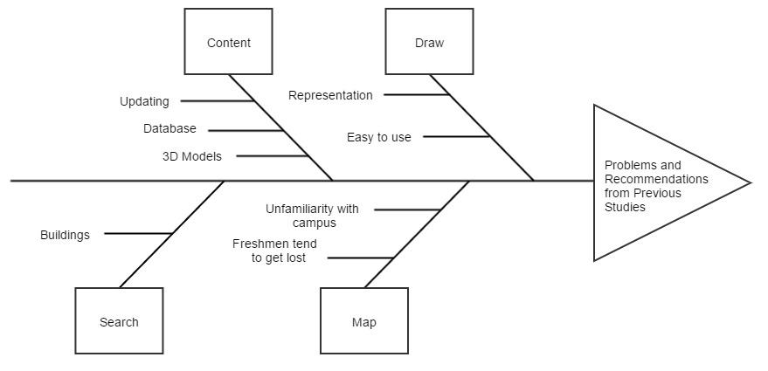

**Figure 1.1** Fishbone Diagram of the System

presents a fishbone diagram showing the problems and recommendations stated in the previous studies that are used as guide by the project developers in the design and development of the system.

## Statement of the Problem

Previous implementations regarding campus maps for IIT recommends a number of advancements and functionalities that can be developed and improved. These systems were found to have no database implementation, no option to add or update information about buildings and structures, no multi-platform orientation and limited searching functionality.

## Objectives of the Study

The project developers adhered to the following objectives to guide them in answering the problem stated in the preceding section.

### General Objective

As illustrated in Figure 1.1, the project developers aim to develop a web-based interactive map of MSU-IIT by applying the recommendations from the systems of Campil et al., Bala et al. and Ferrater et al., unifying their functionalities and integrating them into a single dynamic web-based system.

### Specific Objectives

To be able to meet the general objective of this project, these specific objectives need to be achieved:

1. To design and develop:
   1. A map module to efficiently render 3D structures of MSU-IIT;
   2. A draw module for drawing buildings as polygons and assigning data to them;
   3. A search module for the application; and
   4. A content module with CRUD (Create, Read, Update and Delete) functionalities for all data.
2. To test and evaluate the system using System Usability Scale by the following users:
3. Administrators, as users with content privilege;
4. Students, as one of the end-users;
5. Visitors, as one of the end-users; and
6. Prospective Students, as one of the end-users.

## Scope and Limitations of the Study

This project’s sole focus is on the design and development of an interactive campus map of MSU-IIT. The project developers focused on all the buildings within the campus, excluding external buildings (e.g. College of Medicine and other branches of the MSU-IIT Cooperative).

The project also aimed to develop a simple tool for drawing buildings as lightweight polygons. The system prohibits the user to create and update room perspective since it requires technical skill in the field of 3D development.

The project includes a search module that enables the users to search for buildings and colleges. For security purposes, this module does not include searching for specific faculty members, schedules and rooms with unavailable data. The features of the system are divided and classified by the project developers as hard or soft constraints. Hard constraints are the features that are needed to be developed for the system to work significantly. These are considered top priority and should be developed before other features. On the other hand, soft constraints are the features that can be developed after all the hard constraints are integrated. These are usually treated as “add-on” features since they function dependently from the set of hard constraints. These constraints are found in .

**Table 1.1** Hard and Soft Constraints of the System

|  |  |
| --- | --- |
| **Hard Constraints** | **Soft Constraints** |
| * Map Module * Draw Module * Search Module * Content Module | * Geolocation (IP address or GPS) * Room perspective |

## Significance of the Study

  An interactive campus map allows students to examine the campus size and see how far apart potential classes will be from one another. This allows prospective students to get a feel of the campus without actually visiting it. The system can help students, visitors and prospective students find locations of buildings and/or rooms within the campus and can also provide them with necessary information about certain locations. This also significantly helps in attracting prospective students from distant places to enroll in the university.

The system can also be beneficial to the open source programming libraries used in the design and development of the system especially to OpenStreetMap, OSM Buildings and GLMap. Advancements of the technology used by the developers are contributed to the creators of OSM Buildings and GLMap as these technologies were just recently developed.

## Project Design

**Figure 1.2** Project Design Flow

User-Centered Design (UCD) is an approach that supports the entire development process with user-centered activities, in order to create applications which are easy to use and are of added value to the intended users. By following User-Centered Design, the project developers formulated the project design, shown in Figure 1.2, of the system that follows the following phases: Planning, Analysis and Requirements, Design and Development and System Testing. Each of these phases will be discussed in the Project Methodology.

## Capstone Project Outline

This project document is divided into six chapters. This chapter introduced and discussed the elements present in an interactive map and what were the previous local systems technically lacked.

Chapter 2 briefly discussed interactive maps, its short history and beneficial uses. This chapter also discussed the local systems built with their comprehensive study backgrounds which then summarized. Additionally, other literatures from usability tool to programming libraries were discussed.

Chapter 3 thoroughly discussed the project methodology highlighting the User-Centered Design approach. Included in this chapter the choice of technological libraries as well as how the project comprehensively implemented them through a set of modules.

Chapter 4 contained software specifications and elements that needed to construct the system. Additionally, the development process were also discussed in the later part of the chapter.

A summary from the development process were discussed in Chapter 5 with comparison to the selected features of local studies and their system. Data gathered from the participants of four groups were also comprehensively discussed in this chapter.

Finally, conclusion from the discussion of development process and the data gathered were discussed as well as discussions for further improvement of this study written as set of recommendation and technical limitations.

**CHAPTER 2**

# REVIEW OF RELATED LITERATURE

This chapter provides related topics and studies about the concept of interactive mapping. Also, this chapter covers past researches in the context of interactive mapping in the scope of universities, MSU-IIT in particular. Technologies and principles used will be tackled in the succeeding part of this chapter.

## Interactive Map

Interactive maps can be a great way of displaying useful information in an engaging and attractive way of inviting the user to take action. This technology has given a lot of websites an ability to embed the map on their web pages and use it according to their purpose. It is an additional tool or feature in providing information especially in different academic institutions and businesses (Eder, Nocete, Rances, Tarrosa, & Yanson, 2015). Interactive maps help in keeping visitors engaged and can demonstrate information relevant to the institution in several ways. If we take universities as the most important institutions to inform societies, it becomes clear that universities should also be the platform where information should be utilized most efficiently today (Geymen, 2012).

It is important to evaluate interactive web maps throughout the design process to avoid creating “a cartographic interface that looks great and works well, but does not support the objectives of the intended end users" (Tolochko, 2016). According to Tolochko (2016), participants generally agreed that users should know how to use an interactive map without the need for complex instructions, a notion described in the literature as transparent usability (Robinson, MacEachren, & Roth, 2011)

Evaluations are the primary methods to determine if an interface is successful in its purpose. As cited in the study of Tolochko (2016), the purpose of evaluation is to “provide feedback in software development, supporting an iterative development process” and to “help designers recognize that there is a problem…and plan changes to the correct the problem.” Shriberg (2011) recommended that for the interactive campus map to stay functional, useful and convenient, it will need to be periodically updated It is anticipated that bi-annual updates will be sufficient to capture any new “pride-points” since the last update. Such recommendation poses a challenge on the future project developers in enhancing the system by providing greater detail and new features that support a better user experience. A higher resolution campus image and zoom and drag features support may help improve usability, especially on mobile devices.  Additionally, surveys could be undertaken to analyze user engagement of the map after its implementation. It could make use of open-ended questions to ask how the map could be improved in the future. A link to this survey on the map itself would be an efficient way to evaluate user experience (Shriberg, 2011).

## Interactive 3D Maps

Three-dimensional maps use 3D computer graphics to present geographical information, using perspective representations that, to a certain degree, correspond to the real world. The view presented on a 3D map is more natural, intuitive and easier to comprehend than its 2D equivalent. 3D maps may, but do not have to, use real-3D data and volumetric objects. Earth surface representation that incorporates height information, called 2.5D, complemented with 3D symbols, is decent enough for many applications (Raper, 1989).

3D maps are interactive by definition. Their usability is very restricted without the likelihood of interactive manipulation of the presented view, and unobstructed setting of the wanted perspective. The higher the level of interactivity which is provided, the more useful a 3D map becomes (Góralski, 2009).

However, it is not easy to define what is and what is not a 3D map. As with traditional maps there are diverse types and sorts of geographical presentations that use 3D visualization. A majority of research focuses on the broader subject of application of 3D in geographical visualization, or geovisualization (Kraak, 2001). Representations used in this discipline range from levels of realism to presented data types. In geovisualization, a 3D map may be a realistic reconstruction of a city, or a planned landscape, as in geospatial virtual environments(MacEachren & Brewer, 2003).

This system will focus on a 3D campus map of MSU-IIT that present topography of buildings and structures and use a combination of different types of textures and symbols (3D objects and labels, 2D symbols, lines and polygons, text, numbers, points; selectable or not; multimedia and hyperlinks).

### Studies on Using Interactive Maps in Universities

Roth et al. (2009) presented two web-based interactive maps of the University of Wisconsin-Madison campus: The University of Wisconsin-Madison Interactive Campus Map and the Lakeshore Nature Preserve Interactive Map. Although the two projects represent the same university campus, the former follows a wayfinding-based model of campus mapping while the latter follows an atlas-based model. The purpose of the University of Wisconsin-Madison Interactive Campus Map is to search for, navigate to, and retrieve information about specific features on campus. The purpose of the Lakeshore Nature Preserve Campus Map is to present the rich history and unique geography of the University’s Lakeshore Nature Preserve. The interactive, online development of these maps follows the broader university transition to digital media for retrieving information and organizing student activities. As demonstrated through the two examples, both approaches can produce a useful and engaging tool.

Additionally, Eder et al. (2015) created an interactive campus map with the aid of the Google Map API. Since Google Map capabilities are limited, the researchers planned to overlay the additional features to provide better interactivity to the campus map. These features are 1) the university events, 2) classroom schedules and 3) campus guides. Events provide information about the university activities. Campus guides provide instructional guides and directions on activities like enrollment. University events and campus guides have their own interfaces to give administrators the power to create and alter information. Classroom schedules, on the other hand, obtain its information from the PRISM database of the institution.

The system underwent tests to know whether the problems of the existing campus map have been eliminated and the objectives of the study have been met. The tests were also done to gather information on the outlook of the user about the design and functionality of the proposed system. The researchers were able to know their concerns and suggestions and made adjustments based on the results. This study focused on providing a new way of spreading information which has been achieved due to the new features that the proposed system offers. Because of this, the system has gained positive feedback from the respondents. The existing campus map has its own valuable features but lacks interactive functionalities. The system was made to better provide a friendly user interface making it more beneficial to students, employees and visitors of the institution. The interactive campus map features (1) a campus guide that provides instructional guides and directions that help to direct users, (2) room schedules which also prove effective especially on looking for vacant rooms, and (3) campus events which give information about the upcoming campus events. The system can also provide information on additional queries like amenities, staff, rooms and buildings which the respondents found useful and easy to access, thus, making it a valuable online resource in providing campus information.

Similarly, Nikoohemat (2013) implemented comprehensive indoor navigation systems that not only needs technology platforms but also cartographic and well-designed maps especially for mobile devices. A set of thirty (30) respondents composed of students and staff were asked to answer an exploratory survey. The focus group of the survey were campus map users, staff and students. Some of these students were familiar with the campus and some were not. The survey was also answered by students from other universities who were just enrolled in the campus for one semester and experienced being in other campuses. The survey questionnaire consisted of 20 questions and were distributed in printed form among the focus group.

The study concluded several points from its survey. One of these was that finding lecture rooms was the most important functionality in the application followed by routing, finding points-of-interests and staff offices in undetermined order. Another point was that students preferred 2D maps to 3D maps, preferably without captions. Additionally, using background maps and images had less significance to students; they preferred better functionality than design for the application. Lastly, reliability and fast loading were the key factors for the importance of the smart campus map.

Roth (2013) provided a review of the current state of science regarding cartographic interaction, a complement to the traditional focus within cartography on cartographic representation. Cartographic interaction is defined as the dialog between a human and map, mediated through a computing device, and is essential to the research into interactive cartography, geovisualization, and geovisual analytics (Roth, 2013). The review is structured around six fundamental questions facing a science of cartographic interaction: (1) what can be considered cartographic, (2) why cartographic interaction should be provided, (3) when to provide cartographic interaction, (4) who should be provided with cartographic interaction, (5) where cartographic interaction should be provided and (6) how should cartographic interaction be provided. The review showed how traditional and interactive maps differ so much from each other. It is suggested to create an interactive map based on the science of cartographic interaction.

## Local Existing Interactive Maps

Through an extensive collection of related studies, the project developers obtained the following studies that were developed in the local setting. On this part, the developers will comprehensively tackle the methodology introduced by each existing system with a short evaluative summary at the end of this chapter.

### Lakbay IIT: 3D Virtual Tour of MSU-IIT Campus

A 3D environment is one that exists in three dimensions and is capable of being moved around in and explored. Campus virtual tours are becoming popular in the websites of many colleges, universities and organizations. It has become a favored medium of communicating to prospective students since it will provide useful information about the campus to the prospective students, parents and any interested party.

In a study conducted by Campil et al. (2010), the problem they faced were (1) exploration of the campus was limited because the campus was presented in 2D graphics, (2) prospective students are not given the opportunity to explore the campus in detail before actually going there, (3) guides around the campus were not enough to help the students with directions from a location to another and (4) students usually experienced several inconveniences during times of enrolment because of unfamiliarity. Preliminary interviews claimed that although there were guides (e.g. maps, signage, and posts) found around the campus, those still won’t be enough because people, in general, do not give much attention to those kinds of guides. Most of them were not familiar with the buildings and others didn’t have the resources to visit before busy days (e.g. enrollment, clearance signing).

To address this problem, the researchers developed a desktop application that shows a 3D virtual map of MSU-IIT. This map enabled students to visit different 3D rendered buildings around the campus. However, their application required a standard computer unit or device capable of 3D visualization. 3D visualization requires heavy computer specifications, particularly processor speed, graphics processing speed and memory capacity. A prototype was developed but was limited to desktop use only. The prototype only included individual buildings (e.g. Main Library, College of Business Administration and Accountancy, College of Engineering, College of Education, College of Science and Mathematics. School of Computer Studies and the MSU-IIT Gymnasium).

A set of thirty (30) respondents, all students of the campus, were asked to evaluate the system. These users were limited to navigating the map, generating reports and viewing information. The researchers conducted a usability test during the development phase of the system. Three sets of questionnaires, pre-test, post-task and post-test, were given to the respondents. The pre-test questionnaire was used during the session introduction to verify the qualifications of the participants and gather additional background information to interpret test data.  The post-task questionnaire was used to capture the participants’ perception of the task’s difficulty and to gather relevant comments where applicable.  The post-test questionnaire captured the participant’s overall perception of the system’s usability and specific perception.  User sentiment was also considered during the system test.

The researchers also conducted a usability test after the development phase of the system. The observations gathered during the first system test were recognized and changes were made in the system. The users’ sentiments during the first system test were also addressed causing significant changes to the system’s usability.

After the tests were conducted, the researchers were able to find out the participants’ overall and specific perception of the system’s usability.

In conclusion, the following recommendations were formulated by the researchers: (1) additional collision detection on walls, gates, and other objects, (2) enhancement of the texture of models, (3) inclusion of minute details like room numbers, bulletin boards, cars, computer, etc., (4) additional exploration modes like guided tour mode and walk mode, (5) additional human model for a 3rd person point of view, (6) additional clickable mini map feature, (7) optimization of the system for better performance, (8) additional full screen feature, (9) improvement on sky limitation, (10) additional mouse hover labels of rooms and buildings, (11) inclusion of shortest path feature, (12) additional pop-up bubble of building or college information and (12) additional current location indication.

### Suroy Iligan: A Web-based Virtual Tour of Iligan City

Many locals and tourists want to discover and explore Iligan City but lack the information of famous places to visit. When they do have information, it’s always a simple list of common tourist spots. There are tourists who want to check the place first by looking at multimedia elements, such as photographs and videos before visiting the place. They want to have familiarity with what experience these tourist spots can give them. These tourists depend mainly on what the Internet can provide.

Bala et al. (2012) stated that the problem is that the Iligan City tourism website does not have these elements that would give tourists information about tourist spots to encourage them to visit.

To address this problem, the researchers focused on creating a web-based tour where one can explore the place and give users a first-hand preview on their possible experience if they visit the place. The functionality of the project includes Google Maps integration where locations and information of the places were provided, such as entrance fees and business hours. The system also aimed to develop a virtual tour of the top inns, restaurants and attractions of Iligan City as recommended by the City Tourism Office. The system gathered data that are provided by brochures, tourist guides and web pages. The system is easy to use and aided tourists in finding exact locations of some tourist spots in the city. Every spot has its own location, description, pictures and animations. Panoramic views of suggested places are shown to help tourists have an idea about the spot. The system gives an overview of different destinations that tourists may want to know about. The aim of the system was to supplement the existing tourism website of the city. The system is an interactive environment where users can explore a panoramic representation of different spots in the city.

A set of thirty-five (35) respondents were asked to evaluate the system. The researchers considered the effectiveness of the system to the intended users (locals and tourists). The researchers first showed a prototype to the client and proceeded to Alpha testing. They did some tests and checked all the features of the system and identified those that did not function properly. Beta testing followed in which the researchers let the respondents use and explore the system. The respondents then were given questionnaires to answer. The questionnaires included evaluation on how reliable the system is in providing information about the city. It then served as a guide for the researchers to determine the needed improvements based on the locals’ and tourists’ feedback and attitude towards the system. The questionnaire was composed of different categories: (1) Ease of Use, (2) Content, (3) Technical Aspect and (4) Usability.

In conclusion, recommendations were formulated by the researchers such as (1) making the system kiosk-ready, (2) making the system dynamic by adding backend functionalities, (3) including places that are not commonly visited, (4) making panoramic views in hotels, (5) including big hotels in the city, (6) additional mouse hover labels, (7) a shortest path feature, (8) optimization of the system for better performance, (9) including menus of featured restaurants, (10) adding a current location feature, (11) converting the panoramic tour to 360 view and higher quality of panoramas.

### MSU-IIT Geolocator Information System: An Isometric Virtual Tour of the MSU-IIT Campus

According to Ferrater et al. (2013) some graduates and undergraduates stated that they are not familiar with the structures of the campus due to the lack of reliable and updated campus map. This gave rise to the following problems. Firstly, locating particular areas of the campus was difficult due to lack of information provided and secondly, new students and visitors do not have dependable information regarding locations.

They focused on developing a Flash-based system that displays a virtual tour of the MSU-IIT campus using isometric projection. Isometric projection is a method for visually representing three-dimensional objects in two dimensions in technical and engineering drawings. The system guides users in searching for specific locations in said campus by providing visual and text direction of the most direct route to any college building in the campus. In this study, a kiosk machine was strategically placed in the entrance of the campus, providing initial information about MSU-IIT and short path navigation from the kiosk to any building. Also, the system was limited to one kiosk, disabling the users to freely roam while using the system.

A set of one hundred (100) respondents composed of students and visitors were asked to evaluate the system. Five instructional statements served as tools for evaluating and determining the overall value of the system design. These statements are (1) The overall Geolocator is attractive, (2) The Geolocator’s graphics are of good quality, (3) The Geolocator has a good balance of graphics versus text, (4) The colors used throughout the Geolocator are attractive and (5) The typography (lettering, heading, and titles) is attractive.

With the implementation of the system, an alternative approach of organizing, integrating, and presenting information about buildings was developed. The system offers a way users search for buildings, colleges, offices, and significant people.

In conclusion, the following recommendations were stated by the researchers: (1) Expand the geographic scope of the application, (2) Include an additional guest book that would monitor the number of users of the application, (3) Extend the search for people, i.e., allow the user to see other faculty and staff of the campus, (4) Enhance the graphical components of the system, (5) Extend the search for courses, i.e., allow the user to see graduate programs and the location of each program, (6) Include an additional button to view all the searchable keywords, (7) Include a walking human model for guiding for the shortest path and (8) Optimize the system for better performance.

**Table 2.1** Problem and Recommendations of Previous Systems

|  |  |  |
| --- | --- | --- |
| **System** | **Problem** | **Recommendations** |
| **Lakbay IIT** | Respondents experience inconveniences during times of enrolment. | 1. Collision detection;  2.Texture enhancement;  3. Minor details;  4. Walk mode;  5. Human model;  6. Clickable map;  7. System optimization;  8. Full screen feature;  9. Sky limitation;  10. Mouse hover on buildings;  11. Shortest path;  12. Info window on buildings;  13. Additional current location indication. |
| **Geolocator** | 1. Locating particular areas of the campus;  2. New students and visitors will not have dependable information regarding locations. | 1.Expansion of geographic scope;  2. Guest book;  3. Search for people;  4. GUI enhancement;  5. Search for courses;  6. Button to show all searchable keywords;  7. First person view;  8. System optimization. |
| **Suroy Iligan** | Iligan City tourism website lacks necessary information on tourist spots and services to encourage prospective tourist to visit. | 1. Kiosk application;  2. Backend functionalities;  3. Include new/rare places;  4. Panoramic view for hotels;  5. Include big hotels;  6. Introduce hover labels;  7. Shortest path feature;  8. Optimization for better performance.  9. Include menus of featured restaurants;  10. Add current location feature;  11. 360 view panoramic tour and higher quality of panoramas. |

**Table 2.1** presents the problems and recommendations of existing systems. These were used as guides for the developers in the implementation of the system that suits the needs of the current audience.

### Summary of Local Existing Systems

The need for a virtual campus map was first addressed by Campil et. al (2010) since they have learned that prospective students and visitors experienced several inconveniences on navigating the campus site. Collectively, Bala et. al (2012) addressed the lack of information regarding potential travel spots on the Iligan City's tourist website. Ferrater et. al (2013) highlighted that the lack of reliable and updated content still produced problems to visitors. Even with different methodologies exercised by these studies, potential problems always sprung up that in the long run have rendered these systems obsolete.

Campil et, al (2010) produced a 3D virtual map built as a desktop application which required high end hardware capabilities to render 3D building models. Constructing 3D models alone required excessive time – a problem which was not properly addressed. Furthermore, their system was constructed as a static application and thus data would eventually become obsolete. This problem can also be found on Suroy Iligan not because it was a web application but because the contents in general do not promote interactivity since these data are statically integrated. Additionally, it was also addressed in their recommendation to add backend functionalities to make the system dynamic, thus the problem (Bala et al. 2012).

Although with good remarks on visual representation of MSU-IIT campus data, the problem was also recurrent in the system of Ferrater et al. (2013) since it was built on a kiosk machine with little to no instructions on how to update relevant data. They had the same problem with Suroy Iligan where the data presented was also statically integrated. Additionally, mobility of kiosk machine can be costly on the end of users since they need to find these machines placed on multiple areas around the campus.

Even with these problems present, visualization of different data from the stated systems was potentially viable that their strong suits can still be integrated into one long-term dynamic application.

## Usability

Usability is a quality attribute that assesses how easy user interfaces are to use. The word "usability" also refers to methods for improving ease-of-use during the design process. Usability is defined by 5 quality components: *Learnability, Efficiency, Memorability, Errors* and *Satisfaction*. There are different methods in usability testing (Nielsen, 2012). One of which is the System Usability Scale.

The study provided valuable data concerning the usability of each individual tool; the researchers also derived some conclusions relevant to geovisualization techniques in general. They found that users were, in principle, able to understand and adopt the new ideas of map interactivity and manipulability. However, these ideas needed to be appropriately introduced; people could hardly grasp them just from the appearance of the maps and controls. Understanding the user’s needs and expectations of a map application is essential for effective and transparent interface design (Cooper & Reimann, 2003).

### System Usability Scale

SUS or System Usability Scale is a Likert Scale and a psychometric tool for measuring psychological quality of a product or a system. It provides measurement of people's subjective perceptions of usability in the short time available mostly during evaluation. SUS has become an industry standard, referenced by over 1300 articles and publication (Brooke, 2013).

SUS has proved to be a valuable evaluation tool, being robust and reliable. It correlates well with other subjective measures of usability. SUS has been made freely available for use in usability assessment, and has been used for a variety of research projects and industrial evaluations. The SU scale is generally used after the respondent has had an opportunity to use the system being evaluated, but before any debriefing or discussion takes place. Respondents are asked to record their immediate response to each item, rather than thinking about items for a long time. All items should be checked. If a respondent feels that s/he cannot respond to a particular item, they should mark the center point of the scale.

### Likert Scale

A Likert scale is a common rating format for surveys. Respondents rank quality from high to low or best to worst using five or seven levels. Likert scales were developed in 1932 as the familiar five-point bipolar response that most people are familiar with today. These scales range from a group of categories—least to most—asking people to indicate how much they agree or disagree, approve or disapprove, or believe to be true or false.

### SUS Scoring Methodology

For the system, SUS scoring is used. To calculate the SUS score, all the score contributions from each item are added. Each item's score contribution range from 1 to 5. For items 1,3,5,7 and 9 the score contribution is the scale position minus 1. For items 2,4,6,8 and 10, the contribution is 5 minus the scale position. The sum of the scores is multiplied by 2.5 to obtain the overall value of SU.

### Interpreting SUS Scores

A study by Bangor, Kortum & Miller (2009), through psychometric theory, suggests that multiple questions are generally superior to a single question to which many studies have found that multiple question surveys tend to yield more reliable results than single question surveys. Additionally, multiple interfaces of a product require multiple item questionnaires and single interfaced products require single item questionnaires. This study constructed a useful analog, from 964 usability studies, to classify ranges of SUS Scores into traditional school grading scales, whereas it has been proven useful in declaring strong face validity and the grading scale matches quite well with the acceptability scores, which is another tool constructed by this study of the same reference.

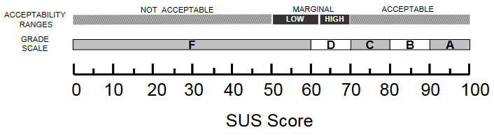

**Figure 2.1**SUS Score Equivalent Scale to Acceptability Range and Grade Scale

Although this project aimed to present an adjective rating as an additional single questionnaire survey to the collection of SUS scores scale interpretation, it was not included in this research because of incompatibility presented in its discussions, whereas the adjective words used were not specific or were not understood enough by the testers.

### Analysis of Scaling Methods Used by Existing Systems

Lakbay IIT used a 5-response Likert scale ranging from one negative response to 4 gradually positive responses (Poor, Good, Average, Satisfactory and Excellent). This makes the product of the study perform with biases in such that the perception to the product itself is always positive. This made the product unreliable enough since it incorrectly conditions the user that the system functionalities are positively usable (Bangor, Kortum, & Miller, 2009).

        MSU-IIT Geolocator Information System used a standard scaling method for their analysis. It also uses the 5-response Likert scale but with wordily equal scaling (Strongly Disagree, Disagree, Neutral, Agree and Strongly Agree). However, their questions were presented in a positive tone, potentially understating the negative traits of the system, which in turn could undermine its long term usability. With this, the researchers would be able to accurately evaluate the system's usability by using SUS scores.

## User-Centered Design

The biggest cost benefit that UCD can provide is by more accurately defining requirements. Ideally, UCD activities should be integrated with other development activities. They should be planned and managed by the development team. Over time, UCD activities will become common practice, and existing members of the team will be able to carry them out. However, usability skills will most probably be needed within the project and if necessary one or more members of the team should possess these skills (Kangas & Kinnunen, 2005).

ISO 13407, or human-centered design process for interactive systems states that *“User-centered design is an approach to interactive system development that focuses specifically on making systems usable. It is a multidisciplinary activity.”*

Several studies have used User-Centered Design, one of which is the study by Góralski (2009) about developing a three-dimensional interactive map to depict geographical information of a place. Another study that used UCD was by Roth et al. (2009) in his study entitled “*The 21st Century Campus Map: Mapping the University of Wisconsin-Madison”* and added that “design is based upon an explicit understanding of users, tasks, and environments.”

## WebGL

WebGL (Marrin, 2011) is an extension of HTML5 canvas element, which is now widely used for developing web applications requiring 3D visualization. It is a 3D graphics API, written in low level language and is based on OpenGL ES 2.0. To avoid complex low level programming, several WebGL-based frameworks have been developed, providing ease of development.

The system greatly uses WebGL in displaying the interactive campus map. It is with this technology that the map can be accessed in any browser anywhere.

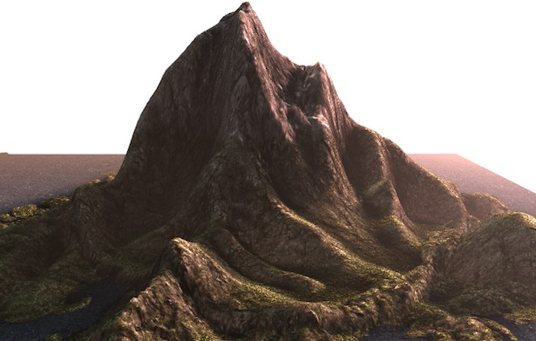

**Figure 2.2** Sample WebGL Representation of a Terrain

## Git Workflow

By far, the most widely used modern version control system in the world today is Git. Git is a mature, actively maintained open source project originally developed in 2005 by Linus Torvalds, the famous creator of the Linux operating system kernel. A staggering number of software projects rely on Git for version control, including commercial projects as well as open source. Developers who have worked with Git are well represented in the pool of available software development talent and it works well on a wide range of operating systems and IDEs (Integrated Development Environments) (Atlassian, 2005).

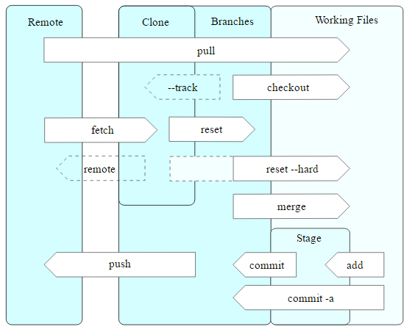

**Figure 2.3** Git Operations

## SOLID Principles

Since the application requires an extensive but robust number of APIs, extra functionalities might get entangled with the other functions or mismanagement in writing the code would result to an unstable product. With this, the researchers will use the five basic principles of object-oriented programming in creating a flexible and ready-to-use and updatable product.

### Single Responsibility

In implementing functions of the system, classes of these functions should be considerably written to one reason to chance. This represents a good way of identifying classes (as to their use) during the design phase of the application.

In the project, single responsibility will be mostly observed in constructing functionalities of the system to minimize confusion but maximizes effectiveness of different tools from different frameworks.

### Open Close Principle

Software entities like classes, modules and functions should be *open for extension* but *closed for modifications***.** This creates flexibility on the child classes by introducing abstraction to its parent class methods. So if a functionality of a system can be reused to another, it is applicable through this principle.

### Liskov's Substitution

Derived types must be completely substitutable for their base types. This ensures that any new derived models or classes to be implemented in the system would not change the behavior of the system or the previous functionalities.

### Interface Segregation

The Interface Segregation Principle states that clients should not be forced to implement interfaces they don't use. Instead of one fat interface, many small interfaces are preferred based on groups of methods, each one serving one submodule. In the system, the principle is useful especially when applying tools of different APIs on a single method or functionality of the application.

### Dependency Inversion

High-level modules should not depend on low-level modules. Both should depend on abstractions. Abstractions should not depend on details. Details should depend on abstractions. With this, the system's modules would be flexible for future modification and/or updates.

## MVC

In object-oriented programming development, model-view-controller (MVC) is the name of a methodology or design pattern for successfully and efficiently linking the user interface to underlying data models. The MVC pattern has been prefigured by many developers as a useful pattern for the reuse of object code and a pattern that permits them to significantly lessen the time it takes to develop applications with user interfaces.

The model-view-controller pattern proposes three main components or objects to be used in software development:

* A *Model*, which represents the underlying, logical structure of data in a software application and the high-level class associated with it. This object model does not contain any information about the user interface.
* A *View*, which is a collection of classes representing the elements in the user interface (all of the things the user can see and respond to on the screen, such as buttons, display boxes, and so forth)
* A *Controller*, which represents the classes connecting the model and the view, and is used to communicate between classes in the model and view.

## Laravel 5

Laravel 5, created by Taylor Otwell and intended for the development of web applications following the model–view–controller (MVC) architectural pattern, is a web application framework with expressive, elegant syntax. Laravel attempts to take the pain out of development by easing common tasks used in the majority of web projects, such as authentication, routing, sessions, queueing, and caching. It aims to make the development process a pleasing one for the developer without sacrificing application functionality. It is accessible, yet powerful, providing powerful tools needed for large, robust applications. A superb inversion of control container, expressive migration system, and tightly integrated unit testing support give developers the tools they need to build any application.

## OpenGL

Open Graphics Library is a cross-language, cross-platform application programming interface (API) for rendering 2D and 3D vector graphics. The API is typically used to interact with a graphics processing unit (GPU), to achieve hardware-accelerated rendering. OpenGL is designed as a streamlined, hardware-independent interface to be implemented on many different hardware platforms.

## OpenStreetMap

OpenStreetMap is an open data project. They release raw data "vector" maps that together with OSM Elements make up the virtual map. With this short discrepancy, OpenStreetMap, compared to competitors like Google Maps, has the greater potential for larger contribution since data presented are raw and open to all. However, Google Maps has more active services and larger data diversity which means that potentially the developed system architecture has already been established (which also costs more). With this considered, the researchers would use OpenStreetMap as one of the main frameworks to be used in the system.

## Leaflet

Leaflet is the leading open-source JavaScript library for mobile-friendly interactive maps. It has all the mapping features most developers ever need. It is designed with simplicity, performance and usability in mind. It works efficiently across all major desktop and mobile platforms, can be extended with lots of plugins, has a beautiful, easy to use and well-documented API.

## OSM Buildings

OSM Buildings is a 3D renderer that uses geometry data from OpenStreetMap available under OpenDatabase License. OSM Buildings works well with OpenStreetMap since every visible element within the OpenStreetMap acts as rendered 3D and 2D resources.

In the initial development of the system, the researchers started with Three.js with Google Maps as framework. But the extensive library of Three.js and the limited free resources from Google Maps hinders the researchers to control the aesthetic design of the developed system. Thus, the researchers decided to use OSM Building and its related library for the system instead.

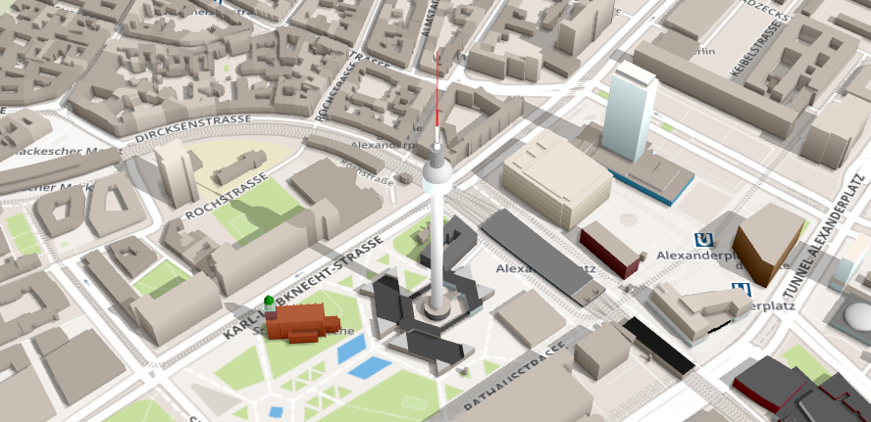

**Figure 2.4** OSM Buildings Representation

## GeoJSON

GeoJSON is a format for encoding a variety of geographic data structures. A GeoJSON object may represent a geometry, a feature, or a collection of features. This format will be used to most functionalities required by this system since the selected frameworks follows the same format as well as it has human readable syntax.

## Summary and Conceptual Framework of the Study

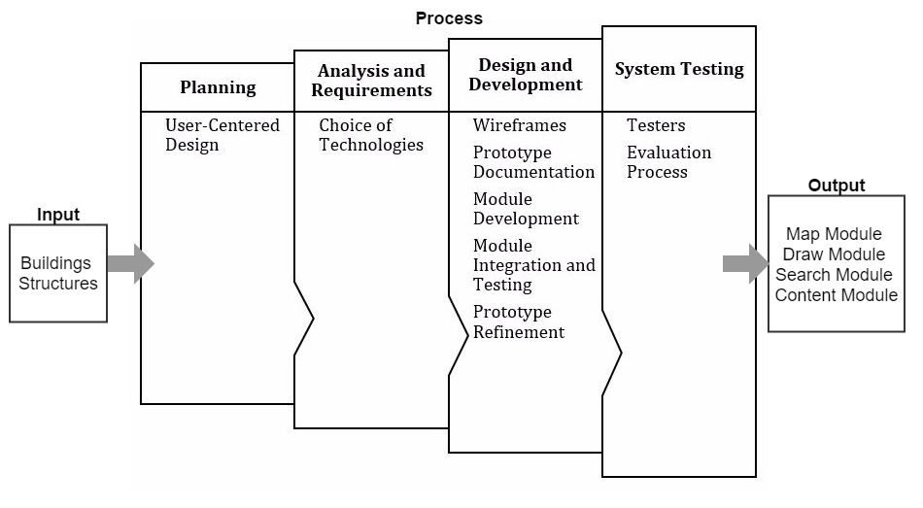

**Figure 2.5** Conceptual Framework

The input for this research is the information gathered by the project developers regarding buildings and structures. The developers will use OpenStreetMap and Leaflet, both of which are open source libraries similar to Google Maps. Both libraries offer a familiar interface for the users and allow users to layer custom information on top of the map and provide a platform that will allow them to add new features, like delivering relevant, location-based information. The project developers will also use OSM Buildings so the interactive map will display lightweight 3D-like polygons as buildings.

The development of this system composes of different modules is the terminal outcome of this research. These modules include a map module for displaying the map, a search module so that users can easily search for relevant data, a draw module so designated users can draw buildings in the map themselves and a content module for the database and CRUD functionalities of all events inside the campus.

**CHAPTER 3**

# PROJECT METHODOLOGY

This chapter shows the methodology used to develop the web-based interactive map of MSU-IIT. The researchers used User-Centered Design in the design and development of the system. presents the phases that the researchers followed.

**Figure 3.1** Project Methodology Phases

## Planning

### User-Centered Design

The web-based interactive map developed for MSU-IIT used User-Centered Design. Roth & Harrower (2008) stated that for interactive maps to work well, developers must place the user front and center throughout the entire development process. Development starts with planning and goes through Analysis and Requirements, Design and Evaluation.UCD isn’t necessarily extensive or costly. A few simple activities initial in development will significantly lessen the overall cost of developing a conventional system.

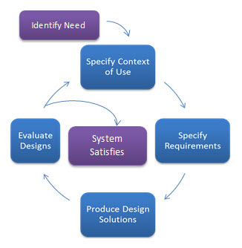

**Figure 3.2** User-Centered Design Process

## Analysis and Requirements

### Choice of Technologies

The project developers used HTML5 (Hypertext Markup Language) along with CSS (Cascading Style Sheets), Laravel, a PHP framework intended for the model–view–controller (MVC) architectural pattern and JavaScript in developing the interface of the system. To aid in the design and layout of the user interface, the developers used Bootstrap 3. Geospatial mapping API libraries used include OpenStreetMap, OSM Buildings, Leaflet and Leaflet Draw.

To store the collected data in the data gathering process, the developers needed database storage. The system used MySQL since it’s used by most Web applications nowadays.

**Table 3.1** Tools and Scripting Languages

|  |  |
| --- | --- |
| **Front-end** | **Back-end** |
| * HTML5 * Bootstrap * CSS * JavaScript * OpenStreetMap * OSM Buildings * Leaflet * Leaflet Draw | * Laravel framework * XAMPP * PHP * MySQL * AJAX |

## Design and Development

### Wireframes

Wireframes were created by the developers for the initial concept and layout of the system. A wireframe, also known as a page schematic or screen blueprint, is a visual guide that represents the skeletal framework of a website. Wireframes are created for the purpose of arranging elements to best accomplish a particular purpose.

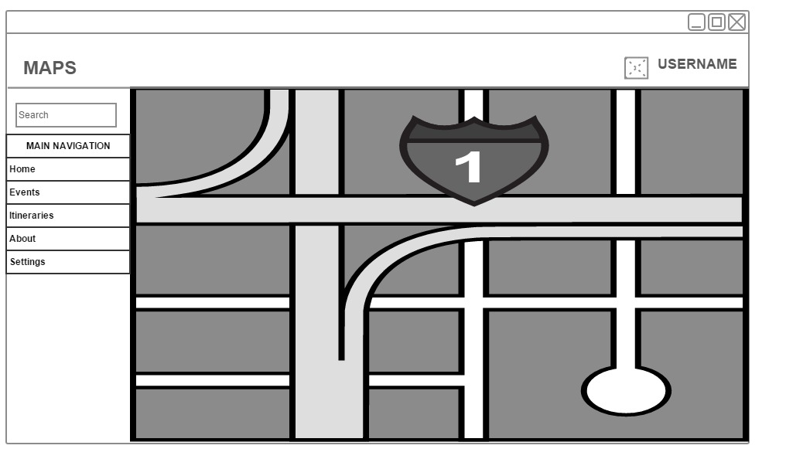

**Figure 3.3** Dashboard Wireframe

### Prototype Documentation

Attempts to construct an early prototype for this system has already been made through multiple trials. The prototypes were based on different mapping API such as Google Maps, OpenStreetMap and Leaflet. The prototype using Google Maps did not meet the requirements of the developers. shows a screenshot of the prototype using Google Maps.

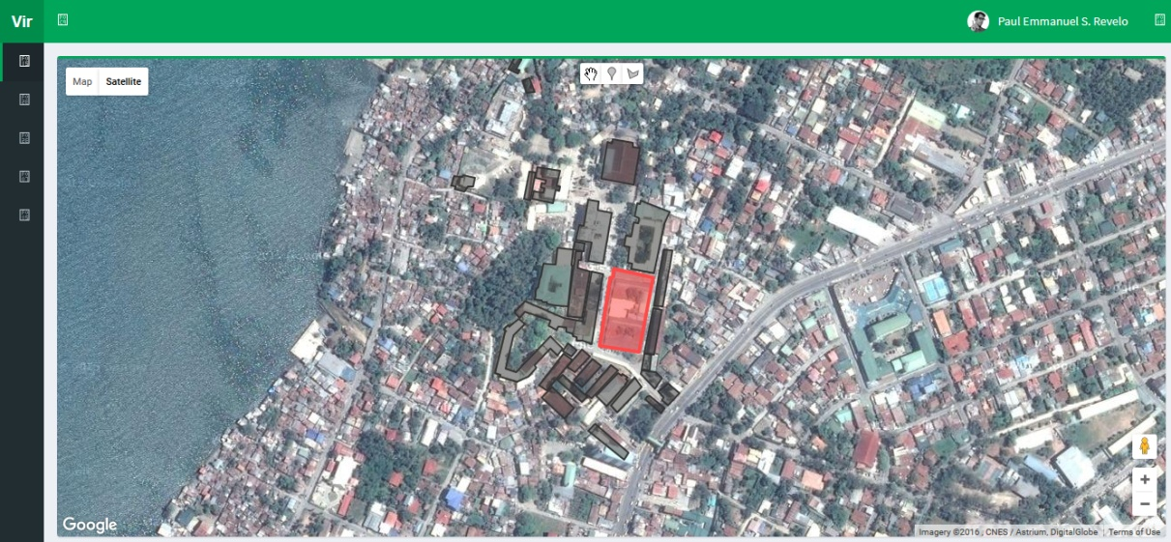

**Figure 3.4** Interactive Map Prototype using Google Maps

After developing the first prototype, the project developers used another mapping API library named OpenStreetMap. This mapping API library, paired with OSM Buildings, a plugin that allows users to load 3D content in maps, met the requirements set by the project developers. shows a screenshot of the prototype using OpenStreetMap and OSM Buildings.

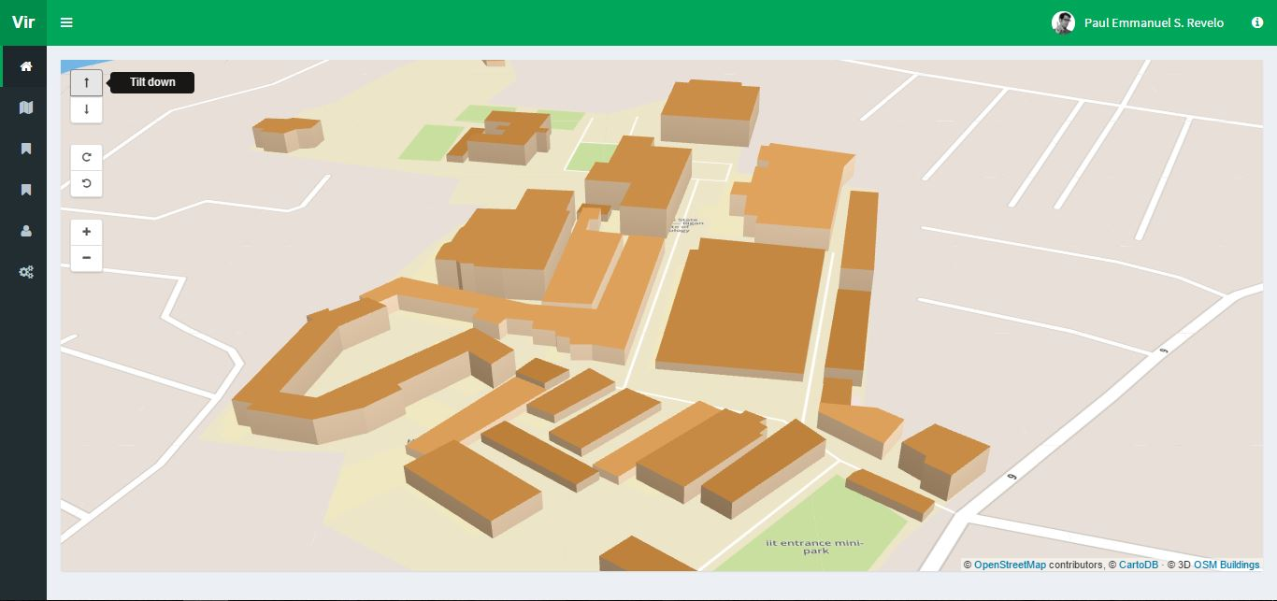

**Figure 3.5** Interactive Map Prototype using OpenStreetMap and OSM Buildings

### Module Development

The specific objectives were interpreted as modules for the system. Proposed features based on the conclusion of the system prototype and usability testing were written as recommendations for further development of the system.

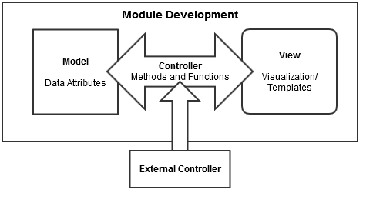

**Figure 3.6** Module Development Process

Initial development of a module started on constructing its model as a class. It is followed by integration process for its controller and testing through visualization on view process. By following programming principles, external controller(s) were made for complexity and readable code. Additionally, its purpose was to provide interconnectivity between modules to be constructed.

**Map Module**

This module counts as a hard constraint of the system as this is the main feature. Development of this module include doing prototypes using visualization technologies (library or framework) and testing whether the technologies used provided what the researchers need for this module. OpenStreetMap was used for the integration of the map and OSM Buildings for the 3D content in the map.

**Content Module**

This module consists of two parts: database and data management. This module is responsible for storing all of the data gathered by the researchers. These include building, structure, room and event information. Also, this module is accountable for the management of these data, which means users can securely access and manipulate the data. Developing this module includes creating a database and creating CRUD (Create, Read, Update and Delete) functionalities using MySQL and JavaScript libraries.

**Draw Module**

This module is responsible in the drawing of low polygon buildings. Developing this module includes the integration of Leaflet’s Draw tools in the map to let the user draw polygons using coordinates, OSM Buildings’ visualization of these coordinates to make 3D buildings and GeoJSON as the initial data format that references to data of buildings involved in the system. These data are from the information provided by the Physical Plant Division.

**Search Module**

This module is responsible for the searching of all data stored in the system. Developing this module includes integrating JavaScript libraries to create the search function and algorithm, HTML to create the elements and CSS to create a style suitable for the overall design.

### Module Integration and Testing

In this section, each module follows MVC (Model, View, and Controller) as the software architectural pattern. In the integration process, the module is created to a class referring it as a model. This model is composed of the module’s data attributes. It is followed by a controller of a different class containing different methods and functions in manipulating the module data.

These provide the system security in accessing the module’s attributes and their interactivity with other modules. In testing, the view component is built for visualization, providing the basic user interface for the module. Additionally, it shows the interactivity between modules, and thus gives the programmers an initial response if problems or bugs are to be found.

### Prototype Refinement

Refining of the system prototype commences once all of the modules are developed. With this, the project developers follow the SOLID Principles as basis in refining the product for this study.

## System Testing

Testing the system as a whole was done through a usability test using SUS (System Usability Scale). Thirty (30) respondents were asked to participate in the said test. With this, the developers can evaluate and measure the usability of all modules based on the different objectives identified.

### Testers

Target testers should be computer literate and are owners of electronic devices capable of web interactivity (i.e. users who have computer units and/or mobile devices). The testers were selected not on the basis of race, religion, gender, civil status or any other classification. Such classifications are not productive for this study.

Preliminary questionnaires were handed out to thirty (30) testers. These testers were given the opportunity to test the proposed system.

Based on the testers’ general information, they were classified into four main user groups: (1) administrators, (2) students, (3) prospective students and (4) visitors.

### Evaluation Process

Answers supplied by the testers were retrieved in Microsoft Excel format. The data obtained were mainly interpreted to discover how users interacted with the system, its navigation and its design. The data was also used to analyze the quality of user-to-user interaction. To this end, a mean for the SUS Score was collected from each user group and was evaluated based on the answers of testers.

**CHAPTER 4**

# WEB-BASED INTERACTIVE MAP OF MSU-IIT

This chapter presents the overall specifications, functional requirements and non-functional requirements of the software developed.

## Systems Requirements Analysis and Specifications

### System’s Functions

The system was developed with a modular approach. Each module has a set of functions. These functions are listed and summarized below.

#### ***Functional Requirements***

The main functional requirements of the system are the following:

* Displays a campus map of MSU-IIT using WebGL.
* Allows the users to navigate around the campus map.
* Presents information of a specific building in the map.
* Stores building and event information in the database.
* Allows management of data through CRUD functionalities.
* Allows the administrator to search, add, edit and delete building polygons in the map.

#### ***Non-functional Requirements***

The most important non-functional requirements of the system are the following:

* The system requires an internet browser.
* The system supports interaction with mouse, keyboard and touch screen.
* The system will run in both 64-bit and 32-bit.

#### *Map Module*

The map module is responsible for the visualization of the campus map. Visualization was done using OSM Buildings’ integration of the coordinates of the buildings. Functions of this module include (1) displaying of the campus map in 3D perspective, (2) navigating around the map and (3) displaying building information on the map.

#### *Content Module*

This module consists of two parts: the database and data management through CRUD (Create, Read, Update and Delete) functions. This module was mainly developed using MySQL for the database. This module is responsible for storing all building and event information and management of such data through the use of jQuery.

#### *Draw Module*

This module is responsible for the drawing of low polygon buildings. This lets the administrator draw polygons using coordinates. These coordinates are saved in the database through the content module. This module is implemented through the use of Leaflet and Leaflet Draw library. The module’s functions include (1) adding a new building polygon, (2) editing the coordinates of a building polygon and (3) deleting a building polygon.

#### *Search Module*

This module is responsible for the searching of all building and event information stored in the system. This module was developed using Datatables JavaScript library.

### Physical Environment and Resources

The interactive map is a web-based application that can be run on any Internet browser. WebGL is used in visualizing lightweight 3D elements in any platform, thus enabling the system to be accessed almost anywhere as long as the user is connected to the Internet.

#### Technical Requirements

System Requirements

**Desktop**

* CPU: 2.33Ghz or faster x86-compatible processor, or Intel® Atom™ 1.6GHz or faster processor for netbooks
* RAM: (WebGL adjusts to the provided memory)
* Video Card: 1GB of graphics memory
* Operating System**:** Windows XP (or higher), Linux or Mac
* Browser**:** Internet Explorer 8.0 or later, latest versions of Microsoft Edge, Mozilla Firefox, Google Chrome, Opera or Safari

**Mobile**

* RAM: (WebGL adjusts to the provided memory)
* Browser**:** Internet Explorer 8.0 or later, latest versions of Microsoft Edge, Mozilla Firefox, Google Chrome, Opera or Safari

#### User Specification

*End Users*

End users can be divided into different user groups: prospective students, students and visitors. The groupings encompasses everyone who is interested to explore the MSU-IIT campus. Educational level and experience is not a constraint but the user should be computer literate enough to know the elements and functionalities of the system.

*Administrator*

        The administrator is capable of adding, editing and deleting buildings and information in the system. S/he is also responsible for the overall maintenance of the system. S/he should be computer literate, has knowledge of how the system works, and should identify the different elements and functionalities of the system. S/he should be a member of the Physical Plant Division of MSU-IIT.

## Design Models

### Context Diagram

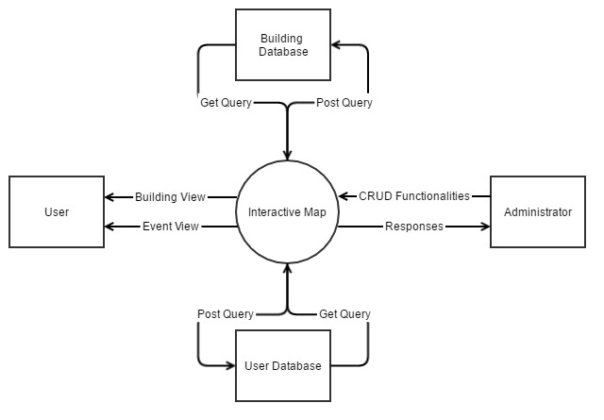

**Figure 4.1** Context Diagram

### UML Use Case Model

#### Use Case Diagram

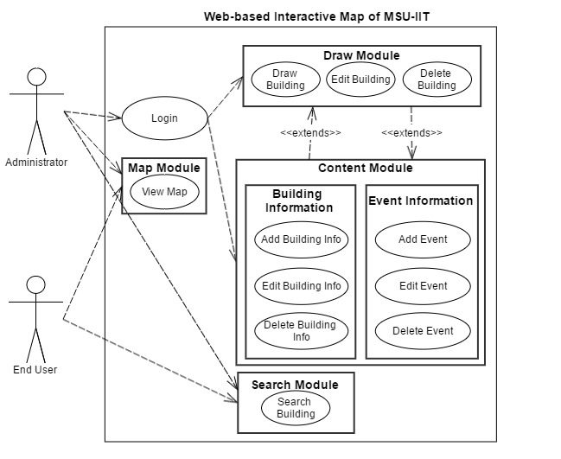

**Figure 4.2** Use Case Diagram for Administrator and User

#### Use Case Specification

##### Login/Logout

**Table 4.1** Login Use Case Specification

|  |  |
| --- | --- |
| **Use Case Name** | **Login** |
| **Use Case ID** | **L1.1** |
| **Description** | This use case describes the actions the administrator will take to log into the system. |
| **Actor/s** | Administrator |
| **Trigger** | The administrator clicks the “Login” button. |
| **Preconditions** | All elements of the page are loaded successfully. |
| **Normal Flow** | 1. The application requests for user’s login credentials. 2. The administrator enters his/her username and password. 3. The administrator clicks the “Sign in” button. 4. The application validates the username and password provided by the user. 5. The administrator is directed to the main page. 6. Use case ends. |
| **Alternative Flow** | 1A. If the user forgot his/her credentials, s/he will click on the “Forgot Password?” link.   1. The administrator is redirected to the “Retrieve Password” page. 2. The administrator inputs his/her email address. 3. The administrator clicks the “Send to Email” button. 4. The application makes the API call for password retrieval. 5. The application sends an email to the email address provided. 6. Use case resumes in step 1. |
| **Exceptional Flow** | If the administrator fails to enter the right username and password, the system will prompt an error message: “The username/password is incorrect.” |
| **Post condition** | The administrator is now logged into the system. |

**Table 4.2** Logout Use Case Specification

|  |  |
| --- | --- |
| **Use Case Name** | **Logout** |
| **Use Case ID** | **L1.2** |
| **Description** | This use case describes the actions the administrator will do to logout of the system. |
| **Actor/s** | Administrator |
| **Trigger** | The administrator clicks the “Logout” button. |
| **Preconditions** | The administrator is in the main page. |
| **Normal Flow** | 1. The administrator clicks the “Logout” button. 2. The application prompts the user if s/he is sure. 3. The use case ends. |
| **Alternative Flow** | 2A. The administrator clicks the “Yes” button.   1. The administrator is back to the login page. 2. Use case resumes in step 2.   2B. The administrator clicks the “No” button.   1. The administrator remains in the main page. 2. Use case resumes in step 2. |
| **Post condition** | The administrator is now logged out of the system. |

##### Map Module

**Table 4.3** View Map Use Case Specification

|  |  |
| --- | --- |
| **Use Case Name** | **View Map** |
| **Use Case ID** | **M2.1** |
| **Description** | This use case describes the actions the administrator or end user will do to view the map. |
| **Actor/s** | * Administrator * End user |
| **Trigger** | * The administrator visits the website. * The end user visits the website. |
| **Preconditions** | * The administrator is in the main page of the website. * The end user is in the main page of the website. |
| **Normal Flow** | 1. Administrator    1. The administrator goes to the website.    2. Use case ends. 2. End user    1. The end user goes to the website.    2. Use case ends. |
| **Alternative Flows** | * The administrator can cancel by clicking the “Cancel” button. * The end user can cancel by closing the page. |
| **Exceptional Flow** | If login credentials are incorrect, the website will prompt the user with an error message saying “Incorrect username/password.” |
| **Post condition** | The administrator/end user can view the map. |

##### Draw Module

**Table 4.4** Draw Building Use Case Specification

|  |  |
| --- | --- |
| **Use Case Name** | **Draw Building** |
| **Use Case ID** | **D2.1** |
| **Description** | This use case describes the actions the administrator will do to draw buildings in the map.  This extends with the content module. |
| **Actor/s** | Administrator |
| **Trigger** | The administrator is in the Map Editor by clicking on the “Map Editor” menu item. |
| **Preconditions** | The administrator is logged into the application. |
| **Normal Flow** | 1. The application displays a map with Leaflet’s map drawing tools. 2. The application also provides a form for the administrator to fill out with information about the building. 3. The administrator draws a polygon using points. 4. The administrator fills out the form provided. 5. The application prompts the user if the process is successful. 6. Use case ends. |
| **Alternative Flow** | The administrator can cancel by clicking the “Cancel” button. |
| **Exceptional Flow** | If the administrator doesn’t fill out all the required fields, the application will prompt the user with an error message saying “You need to fill out all fields.” |
| **Post condition** | A new building is drawn. |

**Table 4.5** Edit Building Use Case Specification

|  |  |
| --- | --- |
| **Use Case Name** | **Draw Building** |
| **Use Case ID** | **D2.2** |
| **Description** | This use case describes the actions the administrator will do to edit buildings in the map. |
| **Actor/s** | Administrator |
| **Trigger** | The administrator is in the Map Editor by clicking on the “Map Editor” menu item. |
| **Preconditions** | The administrator is logged into the application. |
| **Normal Flow** | 1. The application displays a map with Leaflet’s map drawing tools. 2. The administrator clicks on a building in the map. 3. The application gives the user an option to edit the building.   C1. If the administrator chooses to edit the building:   1. The application will display the points of the building; these points can then be manipulated in the map. 2. The administrator will also replace the information about the building. 3. The administrator clicks the “Update” button. 4. Use case ends.   C2. If the administrator cancels:   1. The administrator clicks the “Cancel” button. 2. Use case ends. |
| **Post condition** | The chosen building is updated. |

**Table 4.6** Remove Building Use Case Specification

|  |  |
| --- | --- |
| **Use Case Name** | **Remove Building** |
| **Use Case ID** | **D2.3** |
| **Description** | This use case describes the actions the administrator will do to remove buildings in the map. |
| **Actor/s** | Administrator |
| **Trigger** | The administrator is in the Map Editor by clicking on the “Map Editor” menu item. |
| **Preconditions** | The administrator is logged into the application. |
| **Normal Flow** | 1. The application will display a map with Leaflet’s map drawing tools. 2. The administrator will click on a building in the map. 3. The application will give an option to remove the building. |
| **Alternative Flow** | C1. If the administrator chooses to remove the building:   1. The administrator clicks the “Remove” button. 2. Use case ends.   C2. If the administrator cancels:   1. The administrator clicks the “Cancel” button. 2. Use case ends. |
| **Post condition** | The chosen building is removed. |

##### Content Module

**Table 4.7** Add Building Information Use Case Specification

|  |  |
| --- | --- |
| **Use Case Name** | **Add Building Information** |
| **Use Case ID** | **C5.1** |
| **Description** | This use case describes the actions the administrator will do to add information about a building. |
| **Actor/s** | Administrator |
| **Trigger** | The administrator is in the Map Editor by clicking on the “Map Editor” menu item. |
| **Preconditions** | The administrator is logged into the application. |
| **Normal Flow** | 1. The application will display a map of the campus. 2. The administrator will click on a building in the map. 3. The application will provide a form for the administrator to fill out with information about the building. 4. The administrator will fill out the form provided. 5. The application will prompt if the process is successful. 6. Use case ends. |
| **Alternative Flow** | The user can cancel by clicking the “Cancel” button. |
| **Post condition** | Information about a building is added. |

**Table 4.8** Edit Building Information Use Case Specification

|  |  |
| --- | --- |
| **Use Case Name** | **Edit Building Information** |
| **Use Case ID** | **C5.2** |
| **Description** | This use case describes the actions the administrator will do to edit information about a building. |
| **Actor/s** | Administrator |
| **Trigger** | The administrator is in the Map Editor by clicking on the “Map Editor” menu item. |
| **Preconditions** | The administrator is logged into the application. |
| **Normal Flow** | 1. The application will display a map of the campus. 2. The administrator will click on a building in the map. 3. The application will provide a form for the administrator to fill out with information about the building. 4. The administrator will fill out the form provided. 5. The application will prompt if the process is successful. 6. Use case ends. |
| **Alternative Flow** | The user can cancel by clicking the “Cancel” button. |
| **Post condition** | Information about chosen building is updated. |

**Table 4.9** Remove Building Information Use Case Specification

|  |  |
| --- | --- |
| **Use Case Name** | **Remove Building Information** |
| **Use Case ID** | **C5.3** |
| **Description** | This use case describes the actions the administrator will do to add information about a building. |
| **Actor/s** | Administrator |
| **Trigger** | The administrator is in the Map Editor by clicking on the “Map Editor” menu item. |
| **Preconditions** | The administrator is logged into the application. |
| **Normal Flow** | 1. The application will display a map of the campus. 2. The administrator will click on a building in the map. 3. The application will provide an option for the administrator to remove all information about the building. 4. The administrator will click the “Remove Information” button. 5. The application will prompt the administrator if he/she is sure. 6. The application will prompt if the process is successful. 7. Use case ends. |
| **Alternative Flow** | The user can cancel by clicking the “Cancel” button. |
| **Post condition** | Information about chosen building is removed. |

##### Search Module

**Table 4.10** Search Building Use Case Specification

|  |  |
| --- | --- |
| **Use Case Name** | **Search Building** |
| **Use Case ID** | **S6.1** |
| **Description** | This use case describes the actions the administrator will do to search for buildings. |
| **Actor/s** | * Administrator |
| **Trigger** | * The administrator will click on the search bar in the Buildings page. |
| **Preconditions** | * The administrator has logged in and is in the main page of the website. |
| **Normal Flow** | 1. The administrator will input the name of the building inside the campus. 2. The application will present results of the search. 3. The administrator will choose on the list of results. 4. The administrator will be directed to that building. 5. The application will show details of that building. 6. Use case ends. |
| **Alternative Flow** | 1. The administrator inputs an erroneous search. 2. The application prompts with an error message. 3. Use case ends. |
| **Post condition** | The search will be successful. |

### Activity Diagrams

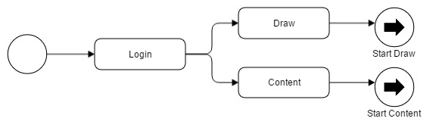

**Figure 4.3**Administrator Login Activity Diagram

To access and update the content in the system, administrators must log into the system to access the Draw and Content Modules which enables them to add, update or delete buildings and other content.

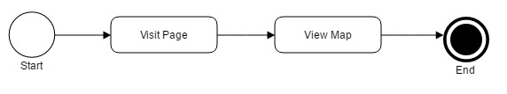

**Figure 4.4** Map Module Activity Diagram

End users, comprised of students, prospective students and visitors, can view the map by visiting the main page of the system. The system then performs a set of tasks such as requesting data information from the database to render the map module.

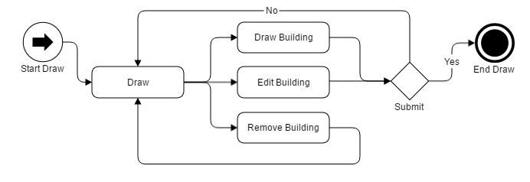

**Figure 4.5** Draw Module Activity Diagram

With authenticated user privileges, the administrator is provided with the Draw, Edit and Remove Building functionalities. In Figure 4.5, Draw Building and Edit Building prompts the user to verify any changes or added information. However, the Remove Building activity would redirect the authenticated user to the main section of the module.

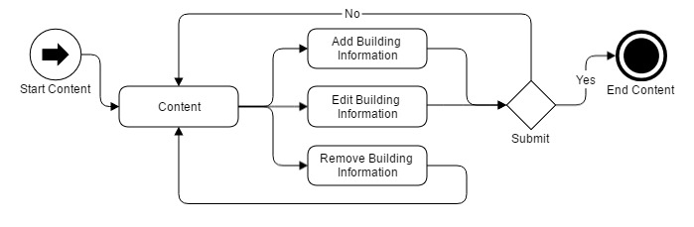

**Figure 4.6** Content Module Activity Diagram

Similar to Figure 4.5, the authenticated user can Add, Edit or Delete building information. Add and Edit activities also prompt the user with a verification message to complete the activity.

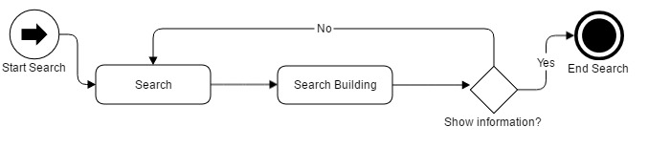

**Figure 4.7** Search Module Activity Diagram

Lastly, search functionality was only integrated within the content module and thus is limited to authenticated users. Users with administrative rights can search and modify the data by clicking it to show its information. Until then the search activity terminates.

### Sequence Diagrams

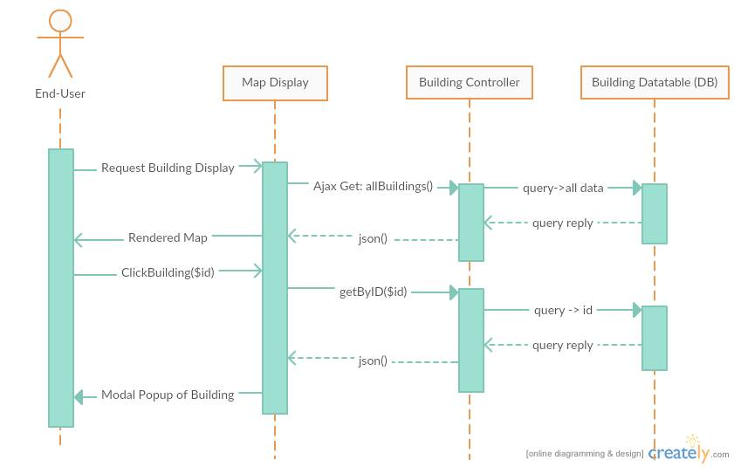

**Figure 4.8** Sequence Diagram for End-User

Through Laravel framework, requesting data is easily achieved. As shown in , the end user, when visiting the front page, issues a request in his/her device to the browser. The browser (which handles the Map Display as view component) then sends Ajax Get request on the building controller. The building controller then sends query to the database of structural data and so on. The database service then queries the reply. The controller converts the data in JSON format which is then arranged by the view component and is further converted into relevant and readable information for the user.

Same goes when the end user clicks on a selected building. The module interprets a get request, the controller interprets the request and the database issues a query.

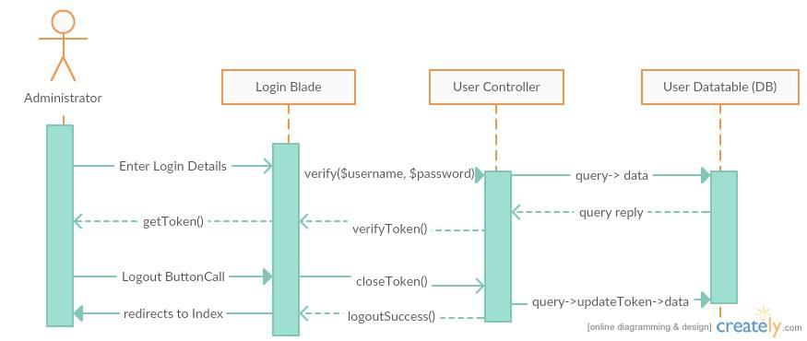

**Figure 4.9** Sequence Diagram for Administrator Authentication

To authenticate a user, s/he must enter designated login details. The view component which is the login blade will issue a verification to the user controller, then the controller queries the request to the database. The database will issue a reply. The controller repacks the reply through the verifyToken function. This will send a set of strings as token for the user activity.

The logout button will be present in the content blades; however, its functionality runs with the controller. The controller sends a query to the database and at the same time closes the verified token of the user and redirects the user to the front page.

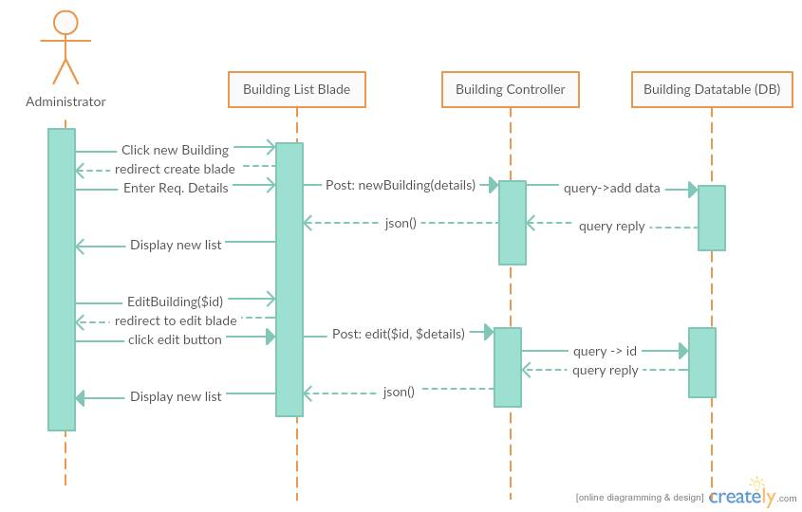

**Figure 4.10** Sequence Diagram for Administrator Create and Edit

Creating building data requires the user to navigate to the Create Blade View Component. Upon redirection to the right blade, the administrator may now enter the required details. The data made will be posted to the controller which is then added to the database. The database then sends a reply which will be packed into JSON format for the view component to display the newly made data.

Additionally, in , Edit Buildings follow the same steps as in creating buildings but requires the user to choose what building to edit.

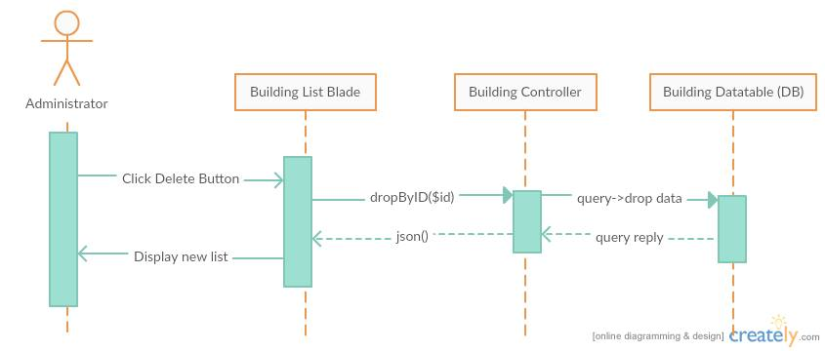

**Figure 4.11** Sequence Diagram for Administrator Delete

Finally, the administrator can delete selected data by a push of a button. The blade will instantly interpret the data to be dropped and will be sent to the building controller. The controller then queries to drop the data from the table, after which the database queries a reply. The controller issues another JSON format data to refresh the list.

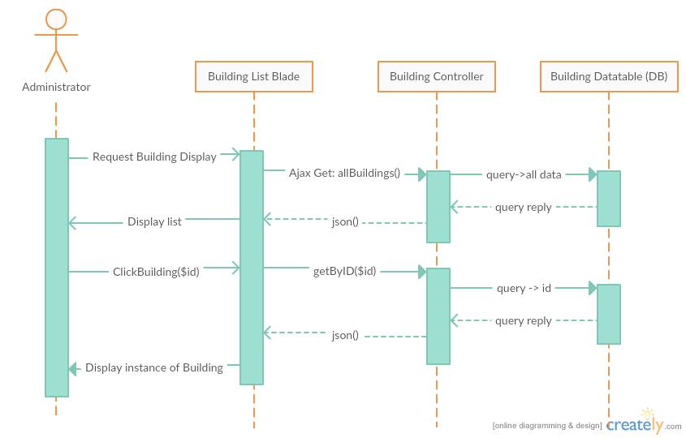

**Figure 4.12** Sequence Diagram for Administrator View

The administrator follows the same sequence as with the End-user in viewing data but the difference is the blade component used.

### Class Diagram

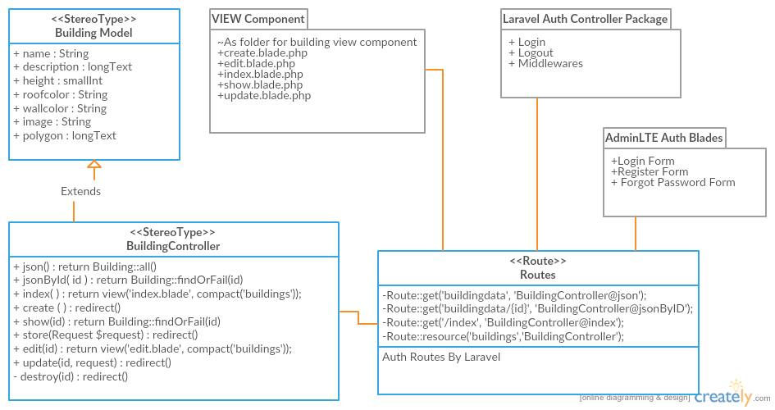

**Figure 4.13** Class Diagram of the Developed System within Laravel Framework

Laravel framework follows an eloquent class hierarchy. Models are constructed through Laravel’s own model class interface. Additionally, this project uses MySQL services. Controllers are also extendedly created from an interface of the Laravel services. Also, routes are premade classes that act as an intermediary to the address route, view components and controllers. With the same practices, the project will make use of premade packages within AdminLTE framework and Laravel for easier build.

### Component Diagram

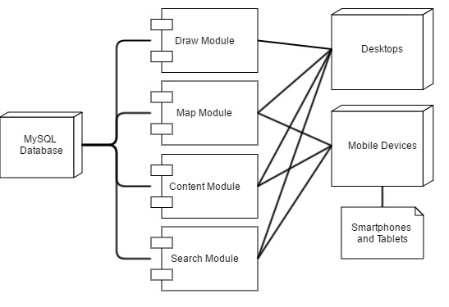

**Figure 4.14** Component Diagram

shows that selective modules only work on specific devices, whereas the map, content and search modules are the only modules available for mobile devices. However, all of the modules can be used for desktop and larger screen device users.

### Deployment Diagram

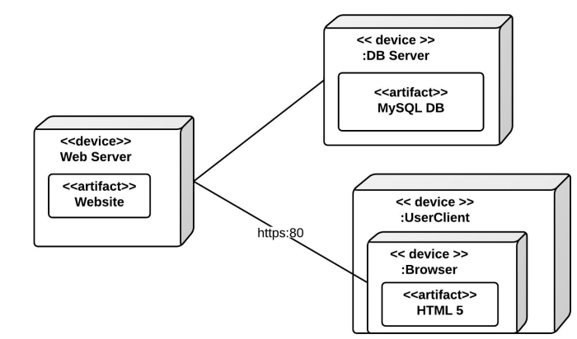

**Figure 4.15** Deployment Diagram

### Database Design Model

#### Entity Relationship Diagram

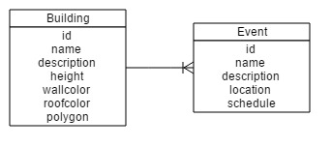

**Figure 4.16** Entity Relationship Diagram

#### Database Schema

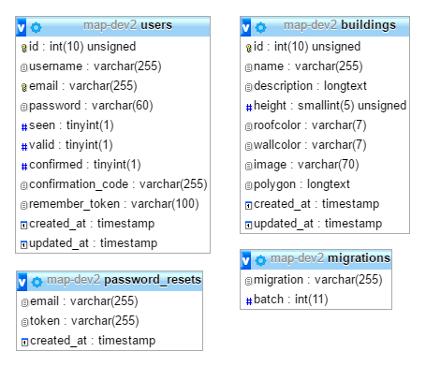

**Figure 4.17** Database Schema

#### Program Structure

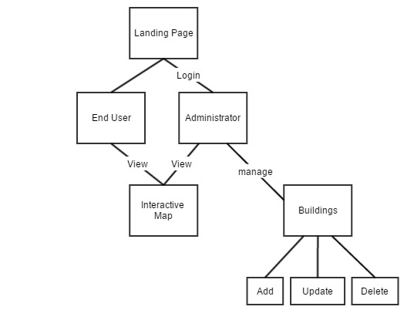

**Figure 4.18** Program Structure of the System

## Development Phases

### Pre-development Phase

With a heuristic approach, the project developers established a system introducing different visualizations of buildings and structures of MSU-IIT.

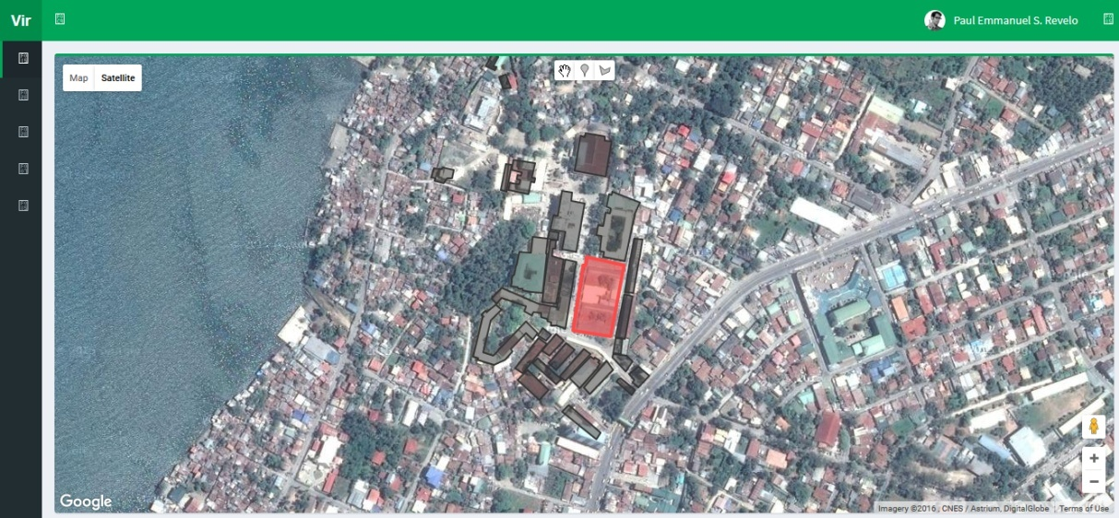

**Figure 4.19** Interactive Map Prototype using Google Maps

Initially, the system used polygon information integrated on Google Maps whichshowcased different sections of the campus represented as 2-dimensional shapes. Because of the inherent insufficiency of 2D in conveying information, the developers aimed to represent buildings with another layer of representation. In line with this, the project introduced isometric visualization by elevating a duplicate copy of the shape of an area added with additional polygon shapes as side or visual perimeter for the buildings represented. However, isometric visualization requires the underlying Google map to be in a 45-degree angle view in order to best represent the buildings and structures.

Isometric representation was limited on Google Maps because some areas are not covered in the 45-degree map visuals especially in the Philippines. Google Maps requires additional financial cost to developers for its different services particularly in 45-degree visual data. This lags the development process, thus, different programming and geographical map libraries were sought after.

### Prototype Development

After considering Google Maps and its API library, OpenStreetMap was finally chosen to be the geospatial data provider for this project. OpenStreetMap is a free open data system which has limited data regarding the Philippines.

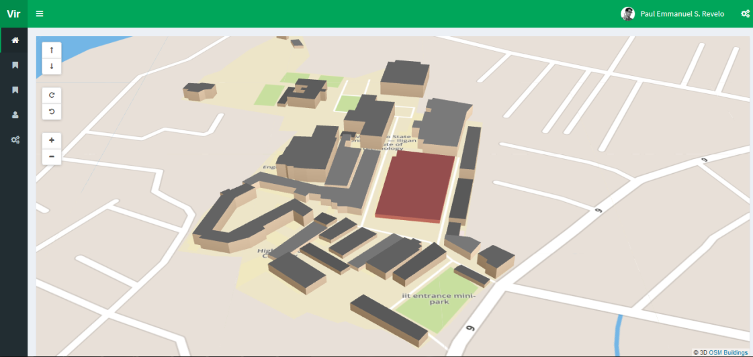

**Figure 4.20** Interactive Map Prototype Using OpenStreetMap and OSM Buildings

Using Leaflet.js library, the OSM canvas was efficiently controlled. Few features of the library were integrated for the functionalities needed in the system. OpenStreetMap API can read GeoJSON format, hence, illustrating 3D low polygons of buildings and structures of the campus became easier to integrate. It was verified by seeding data of the buildings in the prototype. With this, a database can be expected in the system to contain these 3D data and other content.

**CHAPTER 5**

# RESULTS AND DISCUSSION

## Summary of the Development Process

An Interactive campus map is a web based application that can be accessed through a browser. This project aimed to develop and implement a Web-based Interactive Campus Map of MSU-IIT using OpenStreetMap and OSM Buildings. To attain this main objective, the project developers laid out the foundation of a dynamic 3D interactive map by constructing the map, draw, content and search modules.

The development of the system was made possible through the application of the recommendations from the systems developed by Campil et al. (2010), Bala et al. (2012) and Ferrater et al. (2013). These systems were developed as static applications without any form of database and with little to no instructions on how to update relevant data, making the content almost obsolete in the present time. Insufficient searching of keywords was also found on the latter where keywords of relevant content are case-sensitive and limited. The recommendations of the existing systems served as a springboard to this project which now includes the unification and integration of their functionalities into a single dynamic web-based system. The limited capabilities of these systems have motivated the project developers to create an interactive campus map that is useful and easy to access, thus, making it a valuable online resource in providing campus information. The newly-developed system seeks to enable users to find a particular building or facility on campus using an OpenStreetMap.

In the map module, integration of multiple libraries was done mostly within the view components since these were JavaScript libraries that require less in the model component management. First, OpenSteetMap was added to render the map tiles and other services. OSM Buildings was then added to render 3D models of the building structures; however, in the initial prototype, the system used an external file with GeoJSON data of the buildings and structures. To make this component dynamic in displaying 3D maps, AJAX was used to get building data through a selected route which then converted the retrieved data into GeoJSON format. With this, a selected address route for building structures was required for this module to work.

The content module was created by following the model-view-controller (MVC) framework. First, models and their data variables were made using the Laravel Eloquent programming technique which follows the SOLID principles. Initially, building information was migrated to a database using MySQL with a model class within the system directory folder. Inside the model class, data variables were declared. With this, a building controller was made to use this model for data management and other end-user functionalities. The building controller contains different functions or methods that channels the data based on the requirements. For instance, a function that returns building structural data to complete the map module services was added within the building controller. Additionally, an external class called route.php routes these data by providing a registered address to where they are addressed. Lastly, multiple view components or Laravel blade pages were made to show the controlled data. In an instance, a blade for creating building data was done by registering a routed data that is connected to the controller method within the building controller.

To complete this module, CRUD functionalities were later implemented. These pages include a create page for creating/adding building data, a list page for displaying the list of all building data, an edit page for updating a specified selected building and a delete function to delete a specified building. These pages have their own methods within the building controller and can be replicated for other entities as content.

The draw module is a specialized module of content and map modules since it follows the same mechanics; however, the draw module offers more complex services since it relies on the creating and updating of the map and its content. The Leaflet mapping service was integrated. Additionally, Leaflet draw functions were implemented to add new building polygons and/or update building polygons stored in the database.

Lastly, a search module was integrated within the content page for the buildings. Yajra Datatables services was integrated for the search functionality of the content. This function can be integrated to the other content.

## Feature Comparison of Systems

**Table 5.1** Feature Comparison of Systems

|  |  |  |  |  |
| --- | --- | --- | --- | --- |
| Features | Lakbay IIT | Suroy Iligan | Geolocator System | Developed System |
| 3D Graphics | ✔ |  |  | ✔ |
| First person POV | ✔ | ✔ |  | ✔ |
| Interactive |  | ✔ | ✔ | ✔ |
| Informative |  | ✔ | ✔ | ✔ |
| Map |  | ✔ | ✔ | ✔ |
| Desktop-ready | ✔ | ✔ | ✔ | ✔ |
| Mobile-ready/web-based |  | ✔ |  | ✔ |
| Search function |  |  | ✔ | ✔ |
| Updatable Content |  |  |  | ✔ |

The project system achieved 3D representation of building information present in Lakbay IIT System (Campil, et al. 2010) through OSM services. This includes interactivity in first-person Point-of-View with map integration from MapBox map services. Since it was built using up-to-date website technologies, mobility of the system can be exercised to different computer platforms, i.e desktop systems or on smart mobiles. Search functionality features were also present in the developed system that most of the previous system lacked. Finally, dynamic and updatable content is present in the developed system.

## Testing the System

This section presents the results that were obtained during the hands-on testing of the interactive campus map held on the 3rd of May, 2016 from 11AM to 5PM at the School of Computer Studies and Physical Plant Division of MSU-IIT. Testing the system as a whole was facilitated through a usability test using SUS. Thirty (30) respondents were involved in the actual hands-on testing. The project developers were present during the hands-on testing of the system. With this, the developers were able to evaluate and measure the usability of all modules based on the different objectives identified.

## Testers

Target testers were computer literate and were owners of electronic device(s) capable of web interactivity, i.e. users who have computer units and/or mobile devices.

Preliminary questionnaires were handed out to thirty testers. These testers were given the opportunity to test the proposed system. Based on the testers’ general information, they were classified into four main user groups composed of administrators, students, visitors and prospective students.

**Table 5.2** Demographic Profile of User Groups

|  |  |  |  |  |
| --- | --- | --- | --- | --- |
| Testers | Age Range | Male | Female | Total |
| Administrators | 27 - 36 | 3 | 2 | 5 |
| **Students** | **19 - 22** | **4** | **5** | **9** |
| Visitors | 21 - 36 | 2 | 6 | 8 |
| **Prospective Students** | **16 - 17** | **5** | **3** | **8** |
| Total: |  | 15 | 15 | 30 |

As shown in , majority of the test users were relatively young. Being exposed to the rapid proliferation of the Internet, this implies that they are eager to explore new navigational experiences that the newly-developed system has to offer. Such virtual experience will definitely entice prospective students from faraway places to consider enrolling at MSU-IIT. On the other hand, not all users may show interest in using the system frequently. Although the interactive campus map has been optimized for mobile devices, not all users may use it frequently since their mobile devices may not be high end type that is compatible with the system.

**Table 5.3** Responses Collated from Testers for General Question 1

|  |  |  |  |
| --- | --- | --- | --- |
| Q1: Have you used maps or directions as guidance in visiting places? | | | |
| Type Testers | Yes | No | Total |
| Administrators | 5 |  | 5 |
| **Students** | 8 | **1** | 9 |
| Visitors | 8 |  | 8 |
| **Prospective Students** | 7 | **1** | 8 |
| Total: | 28 | 2 | 30 |

As reflected in , most of the respondents are familiar in using maps or directions in finding locations. Two of the respondents, however, expressed that they had not used maps or directions at all. This suggests that maybe they are not used to using maps and are fond of asking for help from people around. This implies that the newly-developed system must have a user-friendly interface for both trained and untrained users. Making it accessible through the internet will surely be a plus factor.

**Table 5.4** Responses Collated from Testers for General Question 2

|  |  |  |  |
| --- | --- | --- | --- |
| Q2: Have you visited MSU-IIT before? (if visitor or prospective student) | | | |
| Type of Testers | Yes | No | Total |
| **Visitors** | 7 | **1** | 8 |
| Prospective Students | 8 |  | 8 |
| Total: | 15 | 1 | 16 |

As indicated in , majority of the respondents have undertaken actual campus visits. One respondent, however, claimed that he/she has not visited MSU-IIT at all. This implies that some users, particularly from far-flung places, simply are unable to visit a campus prior to enrolment due to monetary or time constraints. But by having an online campus map, they will get a feel of the campus without actually visiting it. A far-reaching implication may be that the newly-developed system is not only vital to the recruitment process but can also boost the school’s image.

**Table 5.5** Responses Collated from Testers for General Question 3

|  |  |  |  |
| --- | --- | --- | --- |
| Q3: When inside the campus, have you tried looking for a location but got lost instead? | | | |
| Type of Testers | Yes | No | Total |
| Students | 8 | 1 | 9 |
| Visitors | 6 | 2 | 8 |
| Prospective Students | 6 | 2 | 8 |
| Total: | 20 | 5 | 25 |

As implied in , the use of a traditional campus map proved to be ineffective since a number of respondents claimed that they were not able to locate their places of interest. This implies that the effectivity of the design and functionality of the campus map must be given emphasis for users to explore and navigate. It must be an easily accessible and navigable gateway for users to locate buildings and structures.

**Table 5.6** Responses Collated from Testers for General Question 4

|  |  |  |  |
| --- | --- | --- | --- |
| Q4: Would you prefer to use a virtual 3D campus map than a traditional campus map? | | | |
| Testers | Yes | No | Total |
| Students | 9 |  | 9 |
| Visitors | 6 | 2 | 8 |
| Prospective Students | 8 |  | 8 |
| Total: | 23 | 2 | 25 |

As shown in , almost all of the respondents expressed that they would prefer to use a virtual map over a traditional campus map. A static visual representation of a campus has now become irrelevant and the reality today is that young people access the Internet through a wide range of equally powerful and capable devices; thus, developing an accessible interactive map will further help these users take advantage of these devices. They will then expect that the interactive campus map will be 100% responsive.

## Evaluating the System

After conducting the hands-on pilot testing, a survey was done using the System Usability Scale questionnaires that were given to the same set of testers. The responses of the testers were retrieved using Microsoft Excel. The data obtained were mainly interpreted to discover how users interacted with the system, including the ease of use, ease of finding information, organization of information, functions, capabilities and the overall satisfaction. Additionally, from each of user group, a mean SUS Score was collected and evaluated based on the answers of testers.

## Feedback on System Usability of the Interactive Map

**Figure 5.1** Overall Results of SUS Q1

As illustrated in , majority of the respondents showed interest in using the newly-developed system. This implies that the use of the product had created a successful user experience. To create a successful user experience, designers should consider an interface’s utility, or usefulness, and usability, or ease of use (Fuhrmann & Pike, 2005). This test, however, was limited to usability only of the interactive campus map. Participants in a study on “Contemporary Professional Practices in Interactive Web Map Design” (Tolochko, 2016) generally agreed that both usability and utility play vital roles when soliciting feedback on a web map design. In general, participants agreed that users should know how to use an interactive map without the need for complex instructions, a notion described in the literature as transparent usability (Robinson, MacEachren, & Roth, 2011).

The graph, however, shows that one (1) respondent disclosed that he/she is not interested in using the system frequently. This particular respondent may have suffered from navigational trauma. As described by (Woodruff, 2008)in his blog, navigational trauma is simply put as getting lost due to jumping from place to place and only viewing a portion of the map at any given time. The graph also indicates that one (1) respondent expressed that he/she neither agreed nor disagreed with the statement. This suggests that although the interactive campus map is viewable online via mobile devices, the undecided respondent is not interested in exploring it since his/her device may not be compatible with the system. This further entails that the newly-developed system must remain usable across a range of vastly different platforms.

**Figure 5.2** Overall Results of SUS Q2

As shown in , majority of the respondents found the newly-developed system relatively simple in terms of finding information and lay out of information. They were able to find what they were looking for. It is also capable of accommodating the information needs of users of different age and level of technological competence.

**Figure 5.3** Overall Results of SUS Q3

As illustrated in , Majority of the respondents claimed that the newly-developed system was relatively easy to use. This implies that the system includes an easy-to-implement orientation which is fully optimized with added features customized specifically for viewing on different platforms. The graph also reflects that two (2) respondents neither agreed nor disagreed with the statement. Although the mapping and direction features cater the basic functional and directional needs of the users, the newly-developed system can still be improved to include provisions for the knowledge gaps. The system must bridge between what users know and what they need to know. This may include the use of inclusive design for customer service, online help and training session for the users. Shriberg (2011) also suggested that a student publication write a story about the Interactive Campus Map. The student publications are great places to promote the new Interactive Campus Map. A story in one of these physical publications would be beneficial in reaching people who have not otherwise heard of or visited the school’s website.

**Figure 5.4** Overall Results of SUS Q4

As indicated in , majority of the respondents disclosed that they would not need the support of a technical person to be able to use the system. This proved that the newly-developed system is capable of providing a familiar and user-friendly interface to the users. Hands-on training sessions are deemed irrelevant due to the simplicity of its design.

**Figure 5.5** Overall Results of SUS Q5

As illustrated in , majority of the respondents agreed that the various functions in the newly-developed system were well integrated. It indicates that basic features such as the searching of buildings, 3D representation of buildings, displaying of information and other features boost the system’s ability to reach and engage prospective students and other users. But it is also worth noting that more of the respondents agreed than strongly agreed with the statement. This suggests that the respondents may have seen irregularities within the system but are confident enough that the system has reached and fulfilled the functional requirements set by the project developers. Planned future enhancements, as recommended by the respondents and the project developers, may then be considered by others who wish to further enhance the system.

**Figure 5.6** Overall Results of SUS Q6

As reflected in , Most of the respondents are not convinced that there was too much inconsistency in this system. One of the project’s main goals was to solve the drawbacks or limitations of the previous systems, where various inconsistencies/usability concerns existed. The respondents’ answers show that the system has improved on the previous projects in terms of system consistency.

One (1) respondent was convinced that there was too much inconsistency in the system. This implies that for the interactive campus map to stay functional, useful and convenient, it will need to be periodically updated (Shriberg, 2011). It is anticipated that bi-annual updates will be sufficient to capture any new “pride-points” since the last update. This finding further poses a challenge on the future project developers in enhancing the system by providing greater detail and new features that support a better user experience.

**Figure 5.7** Overall Results of SUS Q7

As shown in , majority of the respondents strongly agreed that most people would learn to use this system quickly. This implies that the campus community will be motivated to use the newly-developed system since its elements are consistent, easily understandable and simple to navigate while simultaneously providing a high level of comprehensiveness and aesthetic value. Additionally, surveys could be undertaken to analyze user engagement of the map after its implementation. It could make use of open-ended questions to ask how the map could be improved in the future. A link to this survey on the map itself would be an efficient way to evaluate user experience (Shriberg, 2011).

**Figure 5.8** Overall Results of SUS Q8

As implied in , majority of the respondents strongly disagreed that the newly-developed system was very awkward to use. This indicates that the respondents manifested freedom from discomfort and displayed a positive attitude towards the use of the product. The awkward feeling of first-time users may be reduced, if not totally eliminated, by further improving the system’s user-friendliness and ease of access.

**Figure 5.9** Overall Results of SUS Q9

As shown in , majority of the respondents disclosed that they are very confident in using the system. The high level of confidence can be attributed to the fact that the newly-developed system has many useful features such as the 3D building representation, first person point-of-view, a keyword search function, and updatable content. Such features arevital, are user-friendly and are visually appealing.

**Figure 5.10** Overall Results of SUS Q10

As reflected on the graph in , majority of the respondents strongly disagreed that users needed to learn a lot of things before they could get going with this system. As long as the map is made interactive, users can readily engage and get information from it. The results show that there is little to no learning curve in using and maximizing the system.

## Scoring System Usability Scale

SUS has a way of calculating the scores of each tester. To calculate the SUS score, the score contributions from each item are added. Each item's score contribution ranges from 0 to 4. For items 1,3,5,7, and 9 the score contribution is the scale position minus 1. For items 2,4,6,8 and 10, the contribution is 5 minus the scale position. The sum of the scores are then multiplied by 2.5 to obtain the overall value of SU. SUS scores have a range of 0 to 100. The standard passing score for SUS is 68, an SUS score above 68 would be considered above average and any score below 68 is considered below average.

## SUS Scores of Each Participant of Each User Group

**Table 5.7** Administrators’ System Usability Results

|  |  |  |  |  |  |  |  |
| --- | --- | --- | --- | --- | --- | --- | --- |
| Participant | 1 | 2 | 3 | 4 | 5 | Total | Overall |
| SUS Score | 87.5 | 80.0 | 90.0 | 92.5 | 80.0 | 430.0 | 86.0 |

As indicated in Table 5.7, the project developers obtained an average score of 86 from the administration group with all of them having scores above 80. This implies that the administration group composed of the members of the Physical Plant Division of MSU-IIT gave this product a passing grade.

**Table 5.8** Students’ System Usability Results

|  |  |  |  |  |  |  |  |  |  |  |  |
| --- | --- | --- | --- | --- | --- | --- | --- | --- | --- | --- | --- |
| Participant | 6 | 7 | **8** | 9 | 10 | **11** | 12 | 13 | 14 | Total | Overall |
| SUS Score | 82.5 | 90.0 | **67.5** | 87.5 | 75.0 | **67.5** | 80 | 87.5 | 90.0 | 727.5 | 80.8 |

As reflected in Table 5.8, the project developers obtained an average score of 81 from the students’ group with 2 of the respondents giving 67.5 score which is lower than the passing grade of 68. However, the average score is 80.8, which more than exceeds the passing grade. This indicates that the product is indeed beneficial to both new and old students.

**Table 5.9** Visitors’ System Usability Results

|  |  |  |  |  |  |  |  |  |  |  |
| --- | --- | --- | --- | --- | --- | --- | --- | --- | --- | --- |
| Participant | **15** | 16 | 17 | **18** | 19 | 20 | 21 | **22** | Total | Overall |
| SUS Score | **70.0** | 80.0 | 90.0 | **77.5** | 90.0 | 90.0 | 100.0 | **77.5** | 675.0 | 84.4 |

As reflected in table 5.9, the project developers obtained an average score of 84 from the visitors’ group with only 3 of the participants having scores lower than 80. This implies that all testers designated as visitors find the product useful and beneficial to visitors in the campus.

**Table 5.10** Prospective Students’ System Usability Results

|  |  |  |  |  |  |  |  |  |  |  |
| --- | --- | --- | --- | --- | --- | --- | --- | --- | --- | --- |
| Participant | 23 | 24 | 25 | 26 | 27 | 28 | 29 | 30 | Total | Overall |
| SUS Score | 80.0 | 97.5 | 95.0 | 95.0 | 85.0 | 87.5 | 87.5 | 80.0 | 707.5 | 88.4 |

As indicated in table 5.10, the project developers obtained an average score of 88 from the prospective students, garnering scores above 80. This suggests that prospective students find the interactive campus map as a useful feature in an educational institution website. A campus guidance system is always a helpful tool for those unfamiliar with the campus to orient them and guide them around the campus.

**CHAPTER 6**

# CONCLUSION AND RECOMMENDATIONS

## Conclusion

The newly-developed system had undertaken hands-on tests to determine whether the limited capabilities of the previously-developed systems have been surpassed and the objectives of the newly-developed system have been met. The previously developed systems have their own benefits but lack interactive functionalities. The newly-developed system was created to better provide a friendly user interface making it more beneficial to students, employees, visitors and prospective students of the institution. It includes the following features: (1) the map module to efficiently render 3D structures of MSU-IIT, (2) the draw module for drawing buildings as polygons and assigning data on them, (3) the search module for the application and (4) the content module with Create, Read, Update, and Delete functions.

The web-based interactive map of MSU-IIT was evaluated through a pilot testing involving thirty (30) respondents. After the pilot testing was conducted, Systems Usability Scale questionnaires were administered to the same set of respondents. Analysis of the outputs generated from the pilot testing as well as the data collated from the accomplished questionnaires proved that the newly-developed system is user friendly, interactive and informative.

The newly-developed system has earned positive feedback from majority of the respondents. Most of them were amazed with its design, functionalities and potential use since it provides geospatial information of the buildings inside the campus with added features such as   
3D graphics, mobile-ready/web-based map, search function for the application, event management and updatable content. Administrators offered to recommend more functionalities of the system since they realized that providing an interactive campus map is not only vital to the recruitment process but also helps boost the school’s image. Prospective students and visitors expressed their utmost appreciation to the development of the enhanced interactive campus map. It is a helpful tool for visitors who are unfamiliar with the campus. It also offers a brand new navigational experience to students. Furthermore, the system provides a way of displaying useful information in an engaging and attractive way by inviting the users to take action. Lastly, it can also be readily viewed by on-and-off-campus users through the Internet, making it truly accessible.

## Technological Limitations

These are the following limitations that were identified after the development of the system:

1. Shortest path–This feature requires additional use of technologies and algorithms.
2. Walk mode – Although First Person Point-of-View has been integrated, walk mode cannot be implemented because it requires a longer development timeframe.
3. Option to Show Proposed or Current Buildings –Latest development of technologies still permit the feature to switch from proposed buildings view to current buildings view.
4. Optimized AJAX data routing – The project developers recommend that future developers would need to optimize and test the performance of the data routes in the system.
5. Highlighting of building after search – Present library, OSM Buildings, limits the highlighting of a building selected after search.

## Recommendations

The following are recommendations gathered from the participants and project developers for others who wish to further improve the system:

* 1. Add a Global Positioning System (GPS);
  2. Add indoor routing;
  3. Add on-screen labels for buildings;
  4. Add and use a true-to-scale legend;
  5. Provide additional visuals for buildings in the future;
  6. Show traffic routes;
  7. Add room details and descriptions;
  8. Add option to show proposed buildings in more complex 3D models;
  9. Further graphical user interface enhancements; and
  10. Improve AJAX data routing.

# Reference List

Allen, I. E., & Seaman, C. A. (2007, July). *Likert Scales and Data Analyses*. Retrieved from Quality Progress Web site: http://asq.org/quality-progress/2007/07/statistics/likert-scales-and-data-analyses.html

Atlassian. (2005). Git Workflow.

Bala, Chiu, & Yparraguirre. (2012). *Suroy Iligan: A Web-based Virtual Tour of Iligan City.* Iligan City: Unpublished Undergraduate Thesis, School of Computer Studies, MSU-IIT.

Bangor, A., Kortum, P., & Miller, J. (2009). Determining What Individual SUS Scores Mean: Adding an Adjective Rating Scale. *Journal of Usability Studies Vol. 4, Issue 3*, 114-123.

Brooke, J. (2013). SUS: A Retrospective. *Journal of Usability Studies Vol. 8, Issue 2*, 29-40.

Campil, L. F., Gomez, J. M., & Paulin, K. D. (2010, March). *LAKBAY IIT: 3D VIRTUAL TOUR OF MSU-IIT CAMPUS.* Iligan City: Unpublished Undergraduate Thesis, School of Computer Studies, MSU-IIT.

Cooper, A., & Reimann, R. (2003). *About Face 2.0: the essentials of interaction design.* Indianapolis: Wiley.

Eder, M., Nocete, C., Rances, G., Tarrosa, E., & Yanson, J. (2015). Web Interactive Campus Map. *INTERNATIONAL JOURNAL OF SCIENTIFIC & TECHNOLOGY RESEARCH*, VOLUME 4, ISSUE 03.

Ferrater, R. R., Gimeno, E. A., & Lipa, A. M. (2013, March). *MSU-IIT Geolocator Information System: An Isometric Virtual Tour of the MSU-IIT Campus.* Iligan City: Unpublished Undergraduate Thesis, School of Computer Studies, MSU-IIT.

Fuhrmann, S., & Pike, W. (2005). *User-centered Design of Collaborative Geovisualization Tools.* Exploring Geovisualiztion.

Geymen, A. (2012, December 3). Interactive web-based campus information system. *Scientific Research and Essays Vol. 7(47)*, pp. 4100 -4108.

Góralski, R. (2009, August). Three-dimensional interactive maps: Theory and practice.

Harrower, M., & Brewer, C. A. (2003). ColorBrewer.org: An Online Tool for Selecting Colour. *The Cartographic Journal, Vol. 40, No. 1*, 27–37.

James, K. (2011, August 18). *Top 5 Reasons You Need An Interactive Campus Map.* Retrieved from nuCloud Web site: https://nucloud.com/blog/top-5-reasons-you-need-an-interactive-campus-map/

Kangas, E., & Kinnunen, T. (2005, July). Applying User-Centered Design to Mobile Application Development. *COMMUNICATIONS OF THE ACM Vol. 48, No. 7 5*.

Kraak, M. J. (2001). Web Cartography: Developments and Prospects. *Cartographic principles* (pp. 53-72). CRC Press.

MacEachren, A. M., & Brewer, I. (2003). Developing a conceptual framework for visually-enabled. *International Journal of Geographical Information Science*.

Marrin, C. (2011). WebGL Specification. *Khronos WebGL Working Group*.

Monitor, I. (2012, September 27). *The power of virtual tours in student recruitment*. Retrieved from ICEF Monitor Web site: http://monitor.icef.com/2012/09/the-power-of-virtual-tours-in-student-recruitment/

Nielsen, J. (2012, January 4). Usability 101: Introduction to Usability.

Nikoohemat, S. (2013). *Smart Campus Map.* Munich: Faculty of Civil, Geo and Environmental Engineering, Department of Cartography.

Raper, J. F. (1989). Key 3D modelling concepts for geoscientific. *NATO Advanced Research Workshop*, (pp. 215-232). Santa Barbara, California, USA.

Robinson, A. C., MacEachren, A. M., & Roth, R. E. (2011). Designing a web-based learning portal for geographic visualization and analysis in public health. *Health Informatics Journal*, 191-208.

Roth, R. E. (2012). *Cartographic Interaction Primitives: Framework and Synthesis.* Wisconsin: University of Wisconsin‒Madison.

Roth, R. E. (2013). Interactive maps: What we know. *JOURNAL OF SPATIAL INFORMATION SCIENCE*, 59–115.

Roth, R. E., & Harrower, M. (2008). Addressing Map Interface Usability: Learning from the Lakeshore Nature Preserve Interactive Map. *Journal of Cartographic Perspectives, No. 60*, 46-66.

Roth, R. E., Van Den Hoek, J., Woodruff, A., Erkenswick, A., McGlynn, E., & Przybylowski, J. (2009). The 21st Century Campus Map: Mapping the University of Wisconsin-Madison. *Journal of Maps*, 1-8.

Shriberg, M. (2011, December 11). *Interactive Campus Sustainability Map.* Retrieved from http://graham.umich.edu/media/files/campus-course-reports/Final%20Report%20Interactive%20Map_12_15.pdf

Tolochko, R. C. (2016, May 23). *Contemporary Professional Practices in Interactive Web Map Design.* Retrieved from http://tolomaps.github.io/assets/Tolochko_Thesis.pdf

Woodruff, A. (2008, June 23). *You are here, but do you know where “here” is?* Retrieved from Andy Woodruff · Cartographer | Blog: http://andywoodruff.com/blog/you-are-here-but-do-you-know-where-here-i/

# APPENDICES

**APPENDIX A**

## Map of IIT

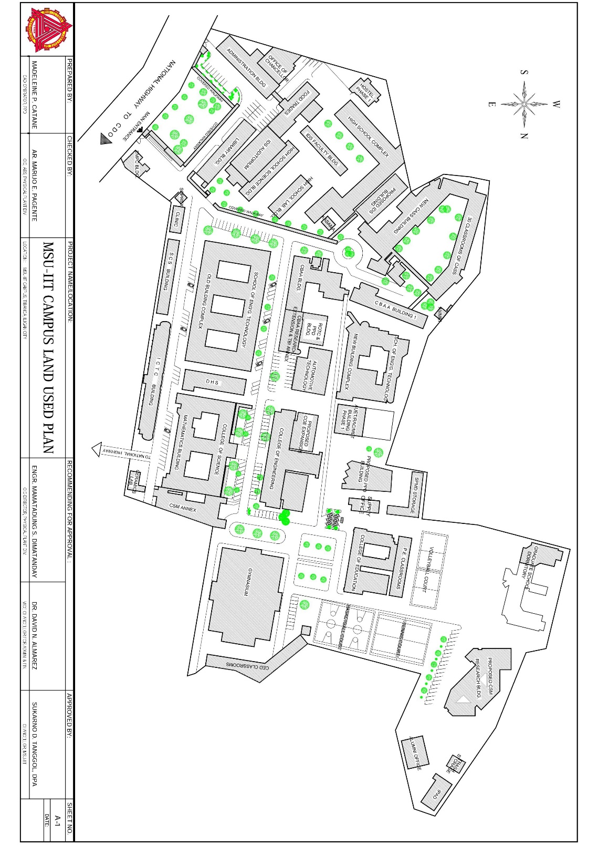

**APPENDIX B**

## College of Arts and Social Sciences Ground Floor Plan

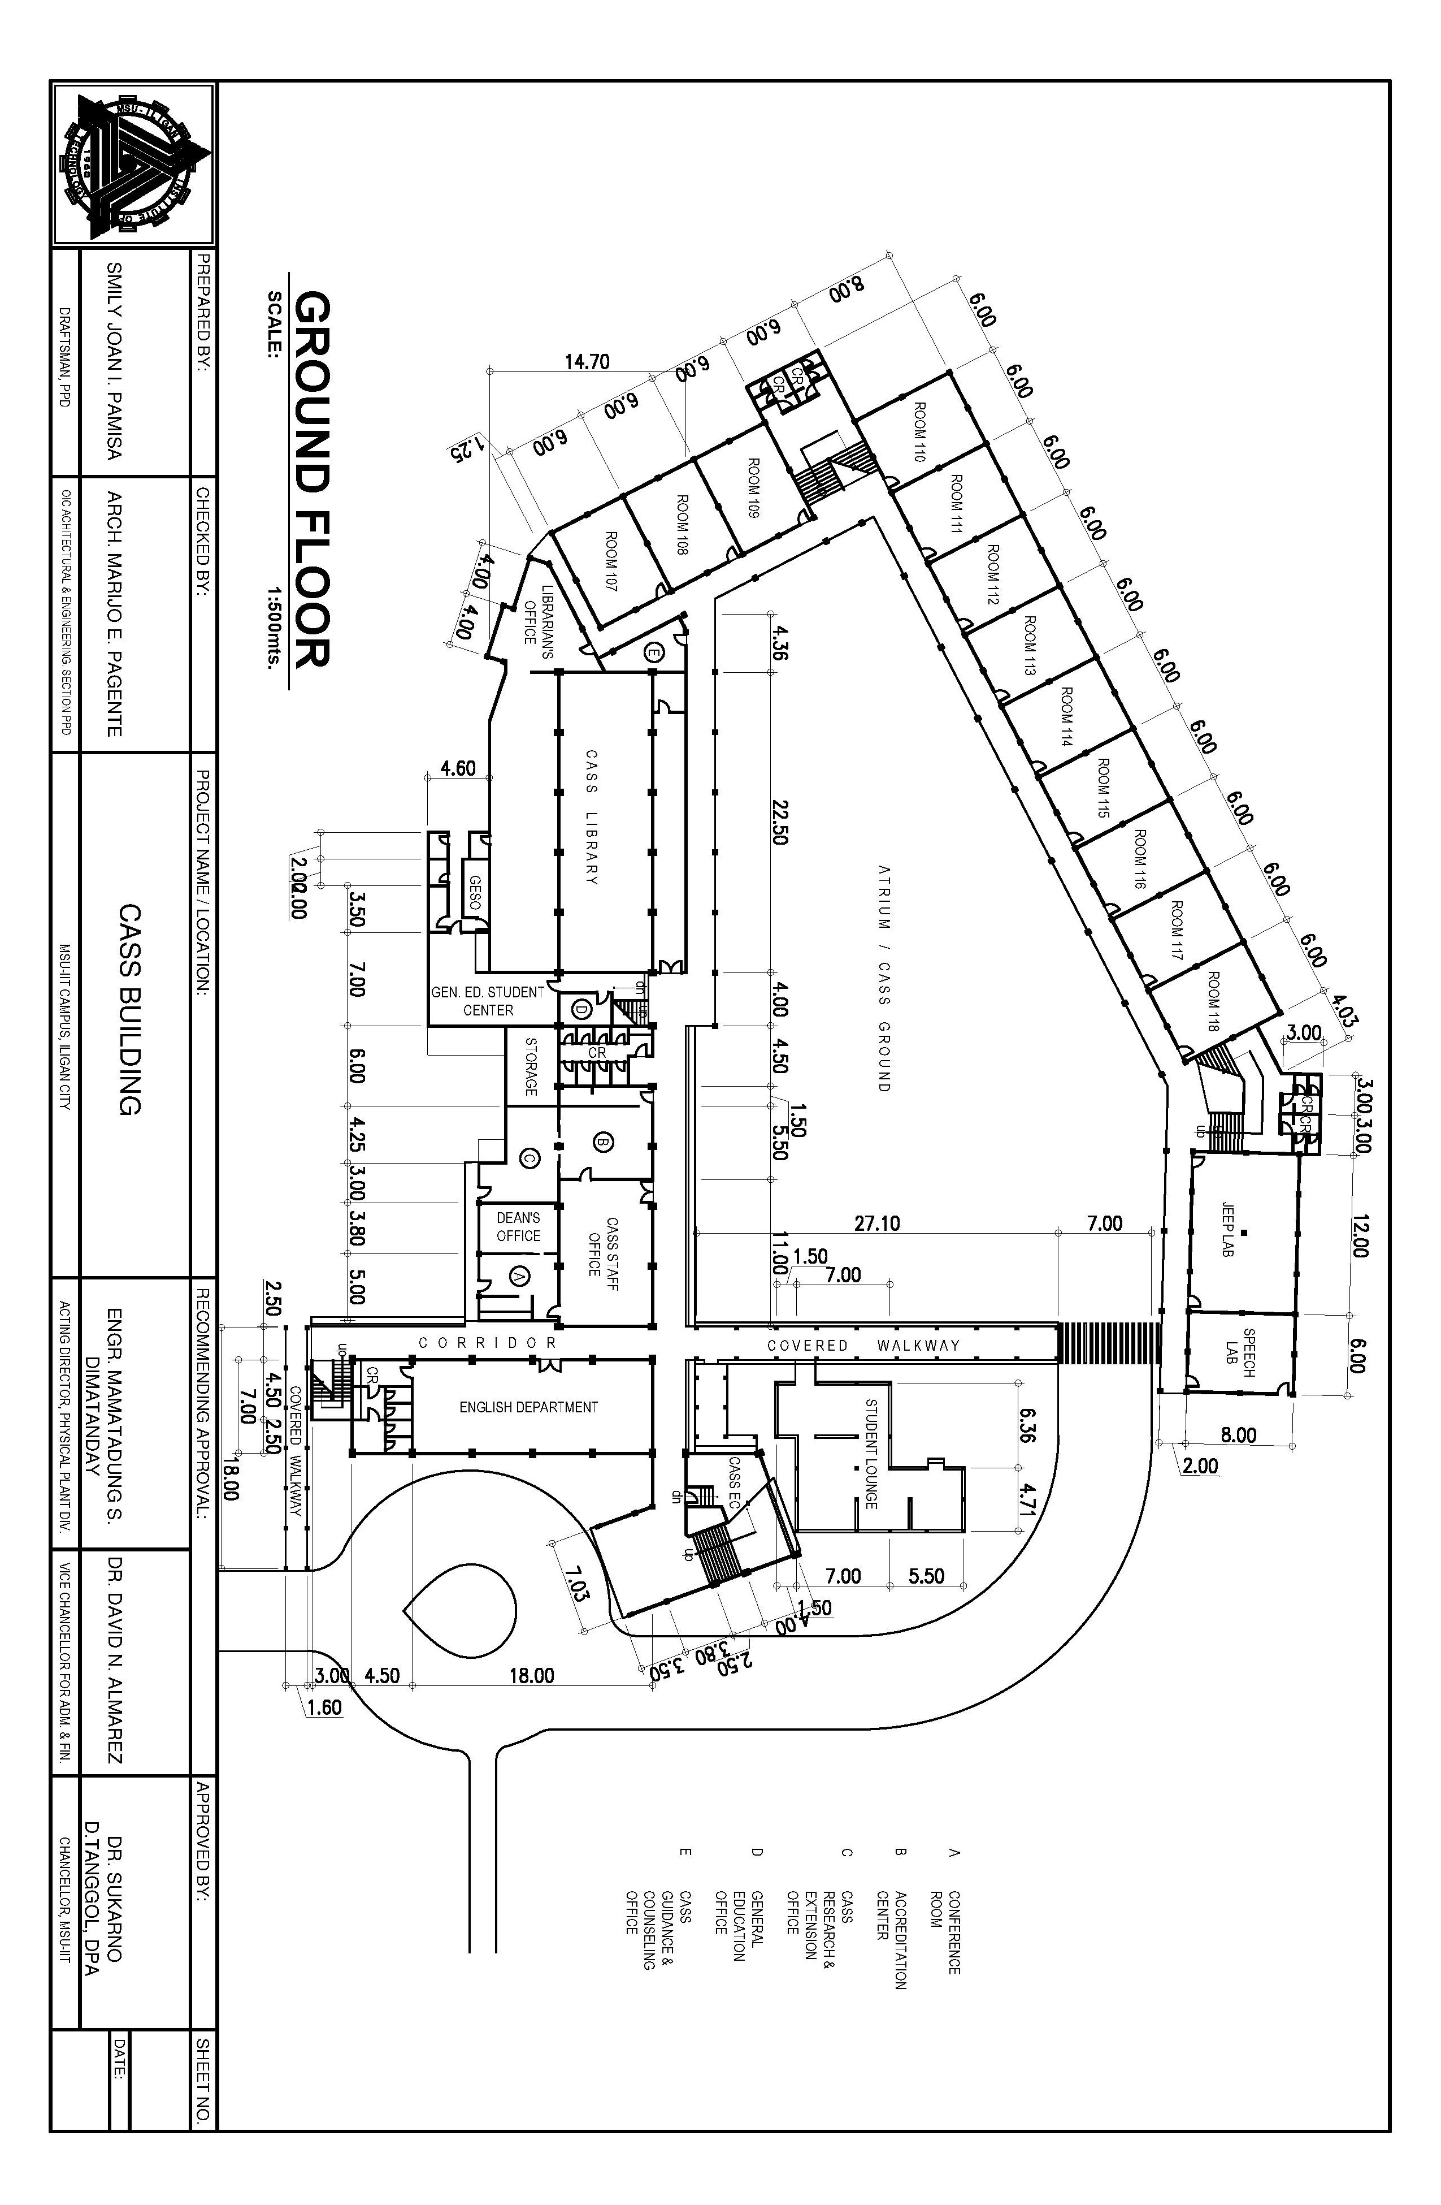

**APPENDIX C**

## College of Business and Accountancy Ground Floor Plan

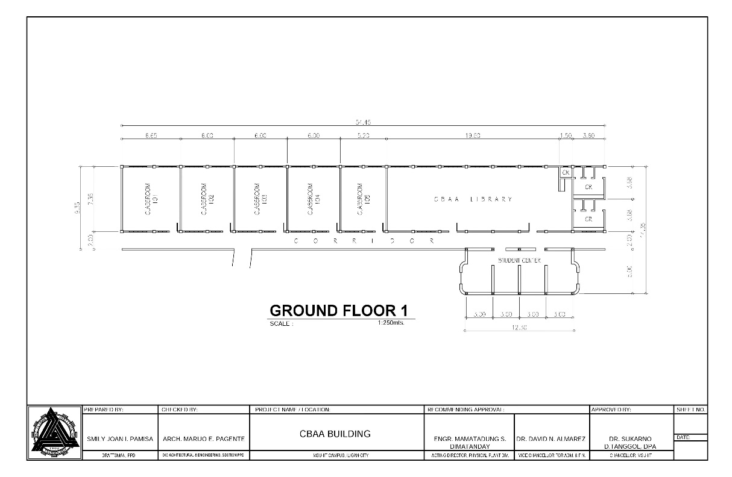

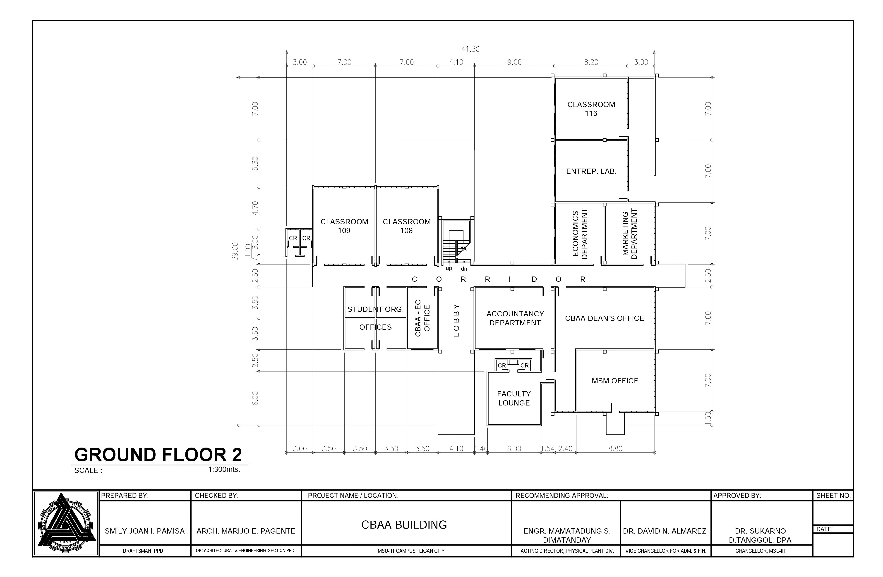

**APPENDIX D**

## College of Education Ground Floor Plan

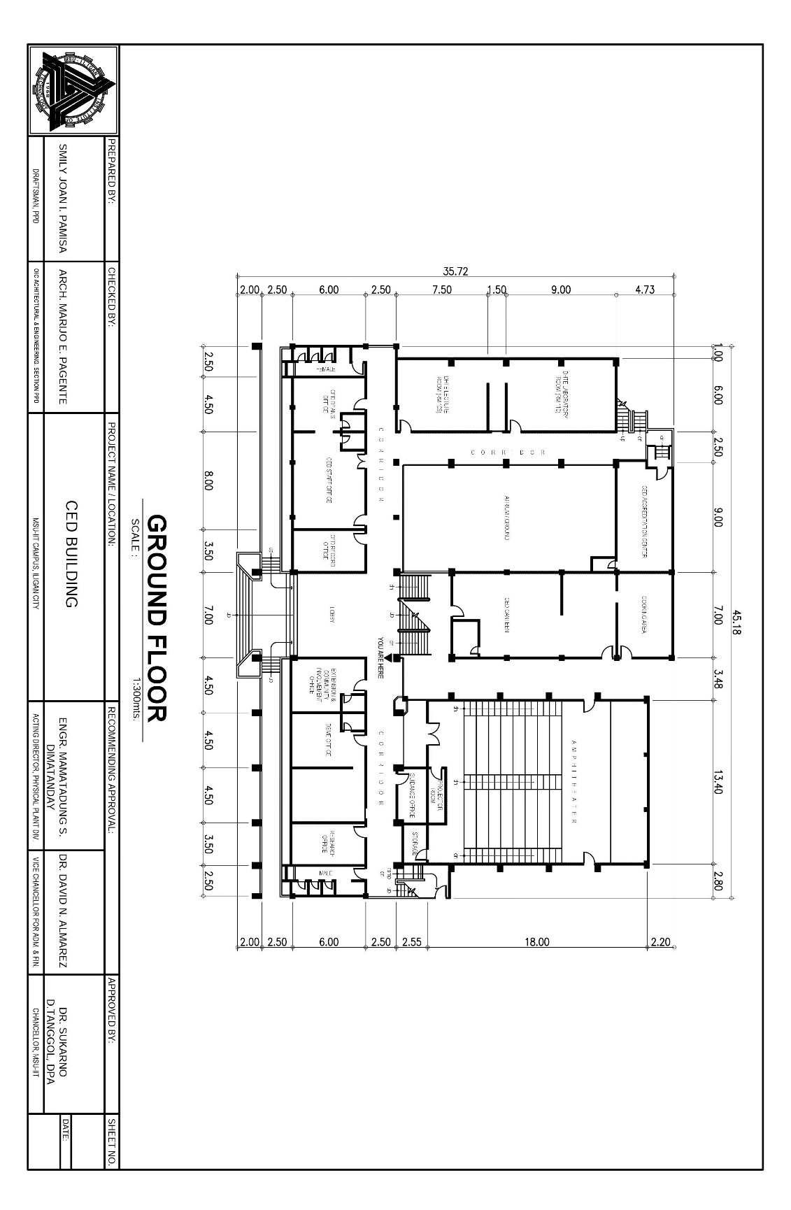

**APPENDIX E**

## Old College of Engineering Ground Floor Plan

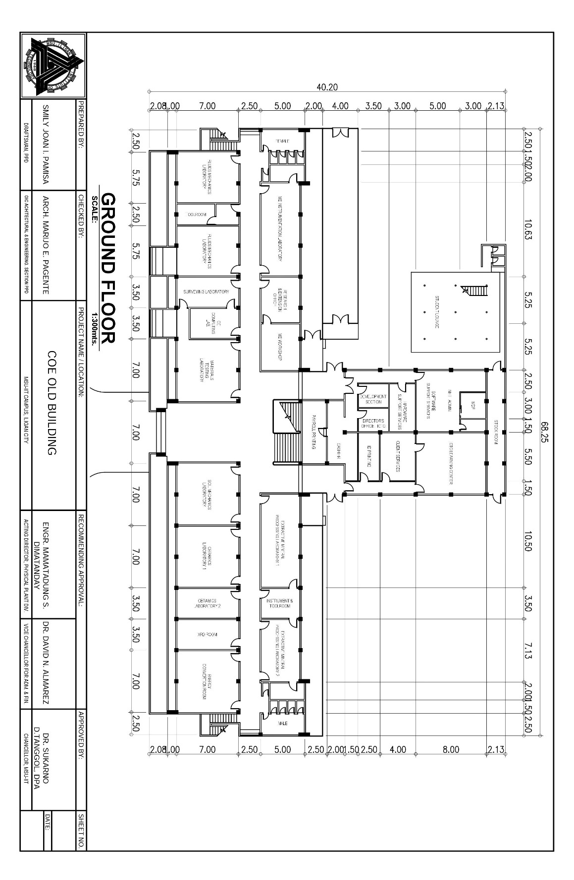

**APPENDIX F**

## College of Science and Mathematics Ground Floor Plan

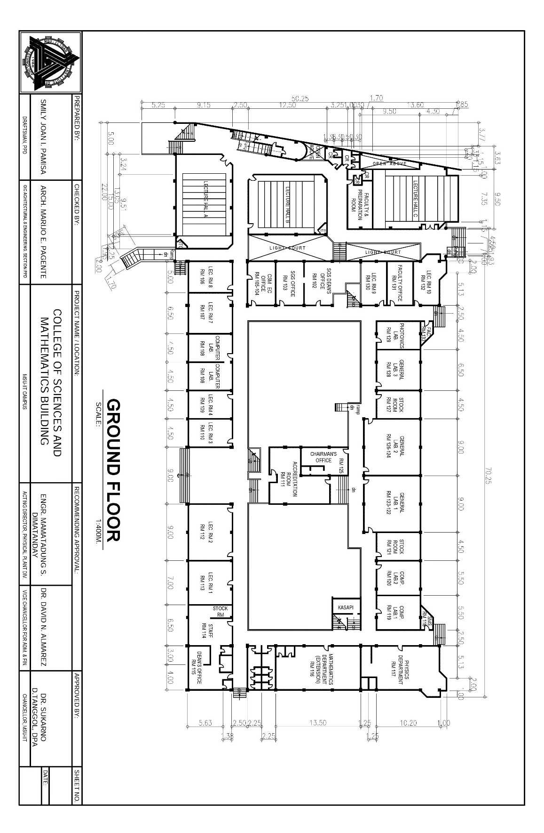

**APPENDIX G**

## ICTC Building Ground Floor Plan

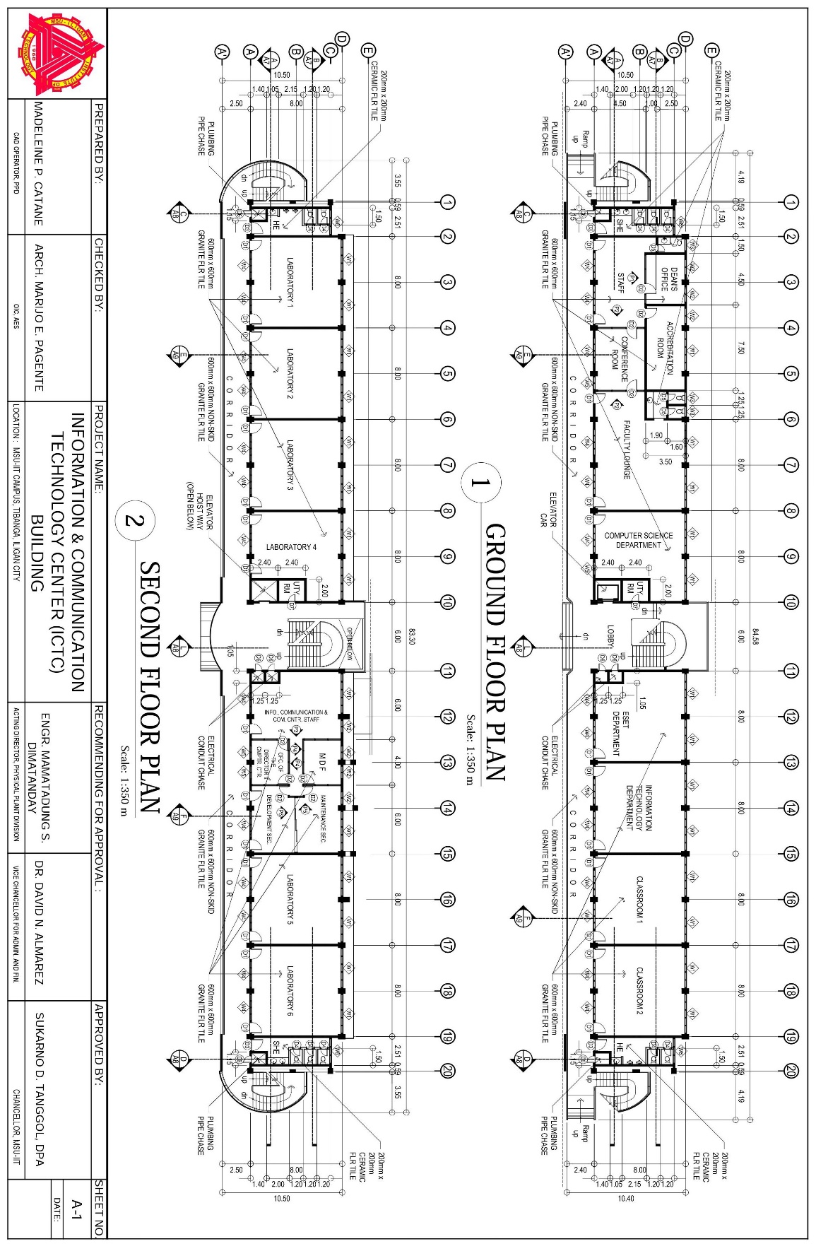

**APPENDIX H**

## School of Computer Studies Ground Floor Plan

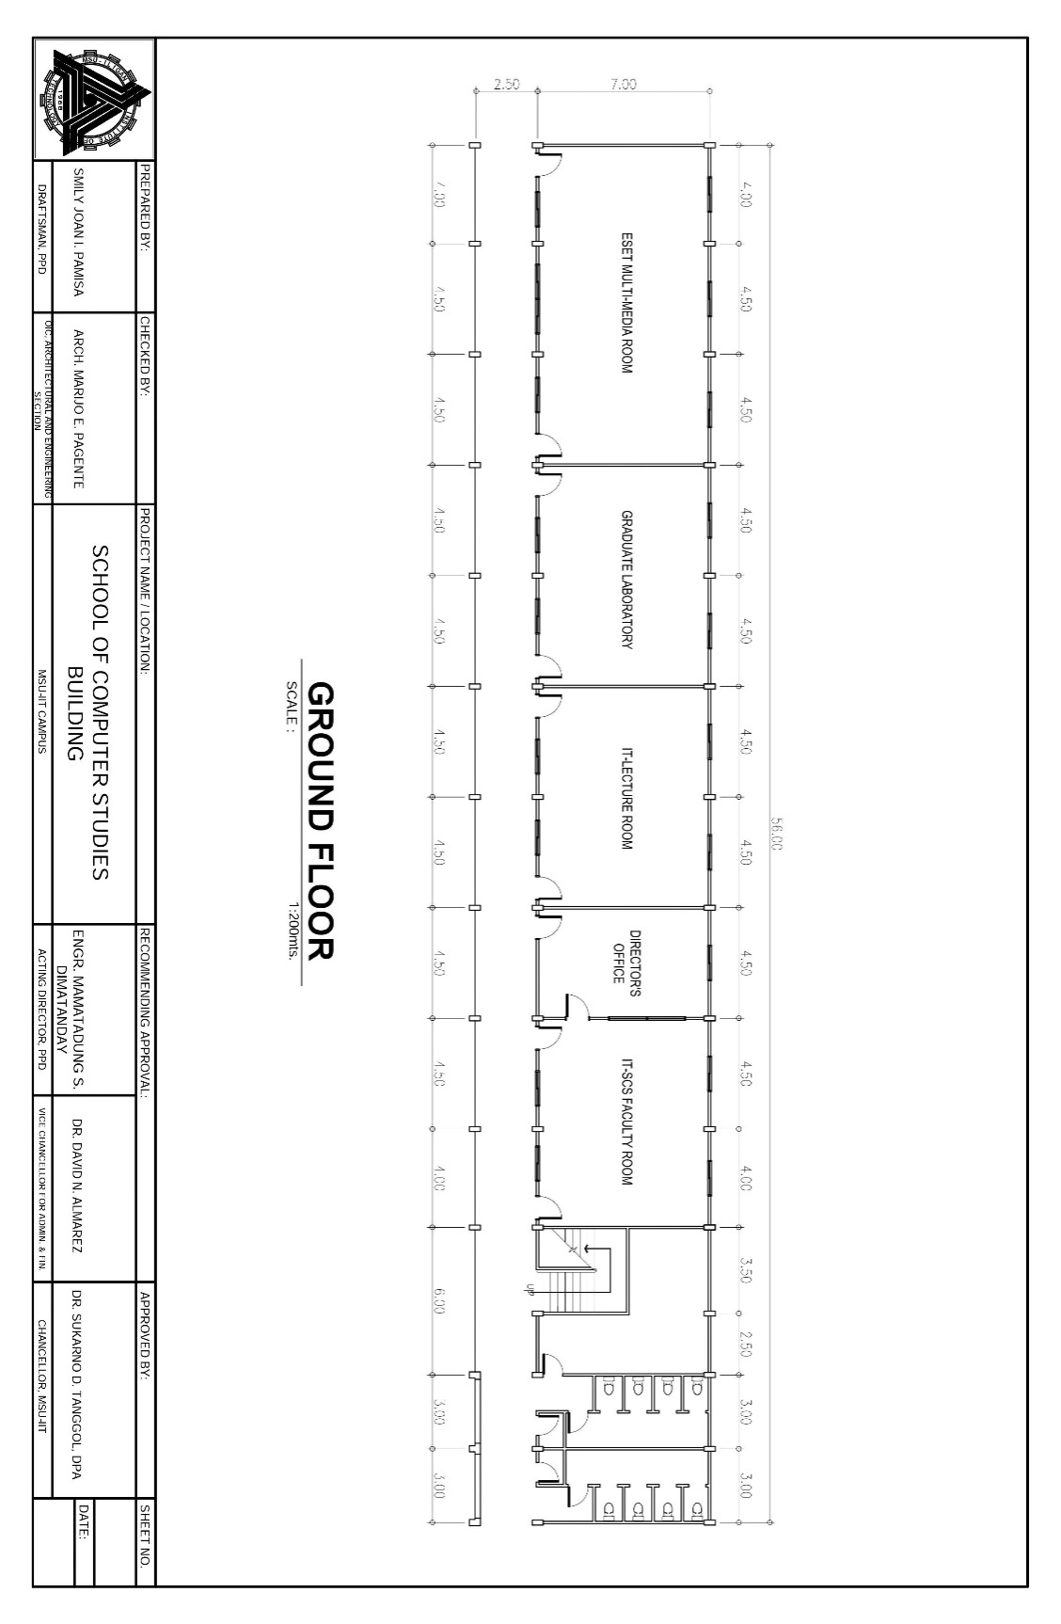

**APPENDIX I**

## General Information Questionnaire

Name (optional): _________________________ Survey ID: ___________

( ) Student

( ) Faculty/Staff

( ) Prospective Student

( ) Visitor

Gender:           O Male O Female

Age: __________

General Instructions: Please answer the questions as directed. Shade the circle corresponding to your answer.

1. Have you used maps or directions as guidance in visiting places?

o Yes

o No

1. Have you visited MSU-IIT before? (if visitor or prospective student)

o Yes

o No

1. When inside the campus, have you tried looking for a location but got lost instead?

o Yes

o No

1. Would you prefer a virtual 3D campus map than a traditional campus map?

o Yes

o No

**APPENDIX J**

## System Usability Scale Questionnaire

General Instructions: For each of the following statements, mark one box that best describes your reaction to the system.

**Strongly      Strongly**

**disagree agree**

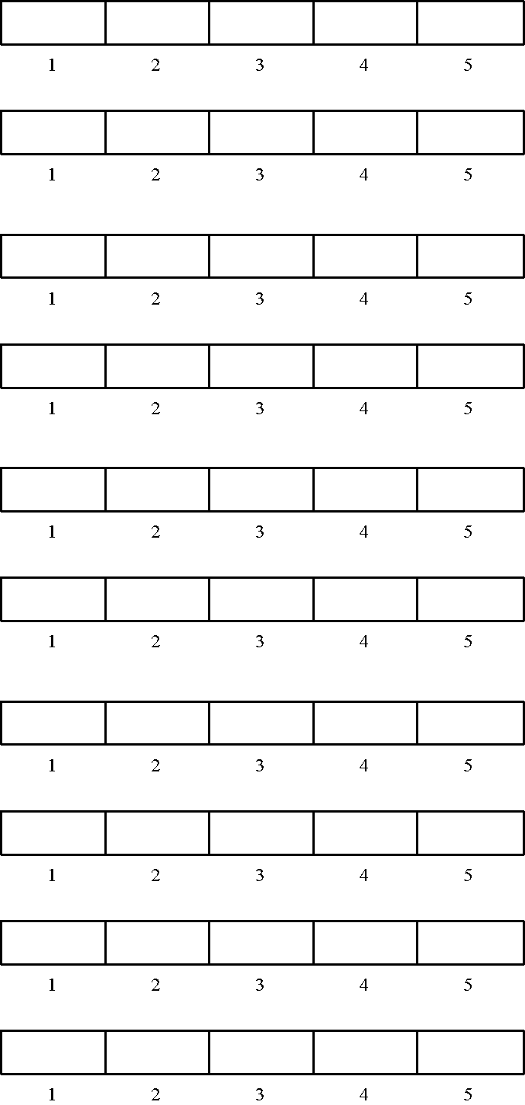1. I think that I would like to

   use this system frequently

2. I found the system unnecessarily

   complex

3. I thought the system was easy

   to use

4. I think that I would need the

   support of a technical person to

   be able to use this system

5. I found the various functions in

   this system were well integrated

6. I thought there was too much

   inconsistency in this system

7. I would imagine that most people

   would learn to use this system

   very quickly

8. I found the system very

   awkward to use

9. I felt very confident using the

   system

10. I needed to learn a lot of

     things before I could get going

     with this system

What can you say about the system? (comments and suggestions)

_________________________________________________________________________________________________________________________________________________________________________________________________________________________________________________________________________________________________________________________________

**APPENDIX K**

## Administrator Task List

Login

type Username: Great@la.rm

type Password: admin

Add Building

Navigate building list

open side navigation list

press building button

Press add Building Button

Enter Valid information

Draw polygon on map

Enter Building Name

Enter Building Estimated Height(2 x perFloor)

Enter Description

Pick Roof Color

Pick Wall Color

Upload Photo of Building

Press add

Edit Building Information

Navigate Building List

Open Side Navigation List

press building button

Select edit building

or Search Building

Click edit button on selected row

Edit Valid Information

Edit Building Name or

Edit Building Height or

Edit Description or

Edit Roof Color or

Edit Wall Color

Press Update button

Delete Building

Navigate Building List

Open Side Navigation List

Press Building Button

Delete Building

or Search Building to delete

Click Delete button on selected Row

**APPENDIX L**

## Summary of Ratings on System Usability of the Interactive Map

|  |  |  |  |  |  |
| --- | --- | --- | --- | --- | --- |
|  | Strongly Disagree | Disagree | Neutral | Agree | Strongly Agree |
| Q1: I think that I would like to use this system frequently |  | 1 | 1 | 14 | 14 |
| Q2: I found the system unnecessarily complex | 15 | 8 | 7 |  |  |
| Q3: I thought the system was easy to use |  |  | 2 | 8 | 20 |
| Q4: I think that I would need the support of a technical person to be able to use this system | 16 | 7 | 7 |  |  |
| Q5: I found the various functions in this system were well integrated |  |  | 3 | 16 | 11 |
| Q6: I thought there was too much inconsistency in this system | 10 | 15 | 4 | 1 |  |
| Q7: I would imagine that most people would learn to use this system very quickly |  |  | 2 | 9 | 19 |
| Q8: I found the system very awkward to use | 18 | 9 | 2 | 1 |  |
| Q9: I felt very confident using the system |  |  | 3 | 12 | 15 |
| Q10: I needed to learn a lot of things before I could get going with this system | 19 | 8 | 2 |  | 1 |

**APPENDIX M**

## Curriculum Vitae

**John Vincent A. Amba**

**Bachelor of Science in Information Technology**

Address: Purok 2, Luinab, Iligan City

Contact #: +639066680425

Email: johnvamba@gmail.com

**EDUCATION**

College Mindanao State University – Iligan Institute of Technology

Bachelor of Science in Information Technology – Major in Multimedia Systems

Bonifacio Avenue, Tibanga, Iligan City

Intermediary Integrated Developmental School

Bonifacio Avenue, Tibanga, Iligan City

High School / Secondary Education Diploma

Elementary Iligan City East Central School (Tambo Central School)

Tambo, Iligan City

Elementary / Primary Education Diploma

**TRAININGS/SEMINARS ATTENDED**

* 10th Iligan City Computing Fair Sept. 19-21, 2012

MSU-IIT

* 11th Iligan City Computing Fair Sept. 23-25, 2013

MSU-IIT

* Google IO 2013

MSU-IIT

* GDG DevFest Feb. 13-15, 2014

Cagayan De Oro

* Lean Manufacturing and Six Sigma Delegate March 13, 2014

Iligan City

* TEDx MSUIIT Nov. 27, 2015

Iligan City

* Trailblaze March 15, 2016

An IS & IT Undergraduate Colloquium

SCS, MSU-IIT

**PROJECTS**

* Structure Analysis Calculator
* Web-based Library for Published Theses - Software Development
* Clean Call – Website Development
* Web-based Interactive Map of MSU-IIT

**EXTRA CURRICULAR**

* 2-time Junior Information Technology Society Level Representative

SCS, MSU-IIT, 2012-2014

* Supreme Student Government Senator

KASAMA - Training and Development Chair

2014-2015

**GROUPS/CLUBS**

* Member, Documentation Committee - SCS, MSU-IIT
* Member, Arts Club - SCS, MSU-IIT
* Member, Chamber Theatre Club - SCS, MSU-IIT

**BASIC WORK EXPERIENCE**

* Client: Prof. Ruben Abucayon

Timespan: Part-time

Position: Software Engineer

* Client: Dana Marzi Horlador

Timespan: Part-time

Position: Software Engineer

* Client: Coding Matters

Timespan: January 2016 – Present

Position: On-the-Job Training

**CHARACTER REFERENCES**

Erik Louwe Sala, MSIT Lomesindo Caparida, Ph.D.

IT Department, SCS, MSU-IIT IT Department, SCS, MSU-IIT

eriklouwe.sala@g.msuiit.edu.ph lomesindo.caparida@g.msuiit.edu.ph

Cenie M. Vilela - Malabanan, Ph.D. Zarah Mae Nubio Fabricante

IT Department, SCS, MSU-IIT IT Department, SCS, MSU-IIT

cenie.malabanan@g.msuiit.edu.ph zarahmae.fabricante@g.msuiit.edu.ph

Atty. Eddie Bouy Palad

Dean’s Office, SCS, MSU-IIT

eddiebouy.palad@g.msuiit.edu.ph

**Paul Emmanuel S. Revelo**

**Bachelor of Science in Information Technology**

Address: 0017 Miguel Sheker Ave., Brgy. San Miguel

Contact #: +639177236610

Email: paulrevelo4@gmail.com

**EDUCATION**

College Mindanao State University – Iligan Institute of Technology

Bachelor of Science in Information Technology – Major in Multimedia Systems

Bonifacio Avenue, Tibanga, Iligan City

Intermediary La Salle Academy

Br. Raymond Jeffrey Rd., Pala-o, Iligan City

High School / Secondary Education Diploma

Elementary La Salle Academy

Br. Raymond Jeffrey Rd., Pala-o, Iligan City

Elementary / Primary Education Diploma

**TRAININGS/SEMINARS ATTENDED**

* 10th Iligan City Computing Fair Sept. 19-21, 2012

MSU-IIT

* 11th Iligan City Computing Fair Sept. 23-25, 2013

MSU-IIT

* Gun Safety & Basic Pistol Marksmanship January 24, 2014

Camp Pintoy

* Juan Big Idea February 22, 2014

Soaring to Broader Marketing Heights

Davao City

* Trailblaze March 15, 2014

An IS & IT Undergraduate Colloquium

SCS, MSU-IIT

* Le Maste August 16-17, 2014

1st Philippine Leadership Masters Congress

Cagayan de Oro City

* GDG Student DevDay Cloud Roadshow September 5, 2014

MSU-IIT

* Cebu Educational Fieldtrip Feb. 13-15, 2014

Cebu City

**PROJECTS**

* Nurse Station Information System
* Juandering Ghost – Game Development
* Social App – Website Development
* Web-based Interactive Map of MSU-IIT
* School of Graduate Studies Inventory System
* Bamboo Technology Resource Center Inventory and Ordering System

**BASIC WORK EXPERIENCE**

* Client: Jonathon MacEachern

Timespan: September 2014 – Present

Position: Project Manager

* Client: Michael Pincus

Timespan: January 2013 – March 2015

Position: Photo Editor

* Client: Donald Contursi

Timespan: June 2015 – December 2015

Position: Social Media Manager

* Client: Ronald Teasdale

Timespan: July 2014 – January 2015

Position: Social Media Manager

* Client: Ally Disch

Timespan: May 2014 – December 2014

Position: Social Media Manager

* Client: Bill Kara

Timespan: June 2014 – August 2014

Position: Social Media Manager

**CHARACTER REFERENCES**

Erik Louwe Sala, MSIT Lomesindo Caparida, Ph.D.

IT Department, SCS, MSU-IIT IT Department, SCS, MSU-IIT

eriklouwe.sala@g.msuiit.edu.ph lomesindo.caparida@g.msuiit.edu.ph

Cenie M. Vilela - Malabanan, Ph.D. Zarah Mae Nubio Fabricante

IT Department, SCS, MSU-IIT IT Department, SCS, MSU-IIT

cenie.malabanan@g.msuiit.edu.ph zarahmae.fabricante@g.msuiit.edu.ph

Atty. Eddie Bouy Palad

Dean’s Office, SCS, MSU-IIT

eddiebouy.palad@g.msuiit.edu.ph